PERSONAL INFORMATION

Address

UAE , RAS ELKHAIMA

Hammam-393034@2freemail.com

Date of Birth

16.08.1985

LANGUAGES

English

French

Arabic

SOFTWARE SKILLS

Word

Powerpoint

PERSONALITY

Communicative

Creativity

Organized

HAMMAM
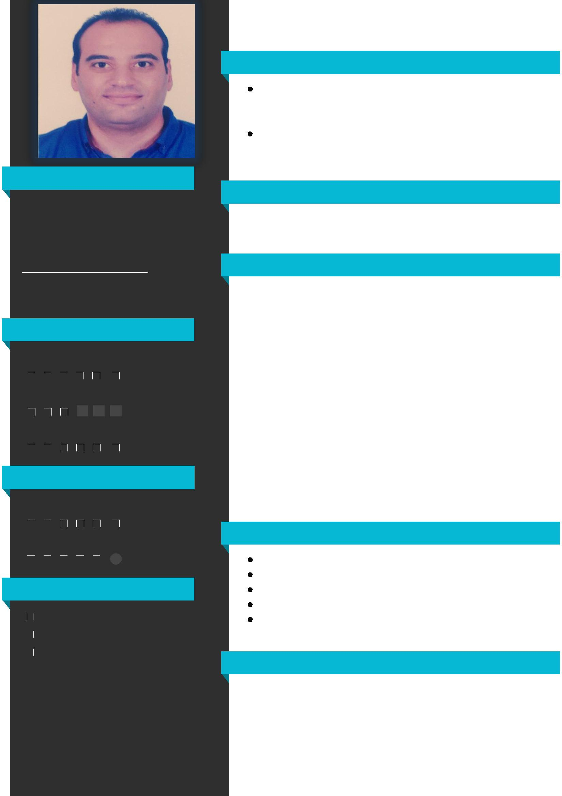

PROFILE

chemist with seven years experience in chemical industries, production planning&control, lean six sigma and total quality management

I am always looking forward to developing my professional skills and looking for a job opportunity to ensure a bright future for me

EDUCATION

Mansoura University

faculty of science - chemistry divsion

EXPERIENCE

07.2011 - present

head of production

Responsibilities: managing and leading the production team; recruiting production staff and consultants; developing and maintaining a detailed production plan

05.2011 - 07.2011

EL IKHWA AL ARAB for plastic

quality engineer

Design of quality control system

07.2009 - 09.2010

Miliraty service in republic guard

head of trainning and operations office

Develop the annual training plan

CERTIFICATION

Production planning & control

preventive & predictive maintenance

Quality control circle training & 5S

ISO 9001

preparation of workers in enviromental departments in the industrial zones

HOBBIES

Technology science Business Reading

