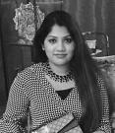

ABOUT ME

I am a highly motivated architecture graduate from the American University in Dubai. My education at the American University in Dubai has been constructive as I got the opputunity to learn from an international multi-disciplinary staff. For my Final year thesis I explored Dubai's humble past and its link with architecture. Through my work I aimed at providing a substantial glimpse into the history and evolution of Dubai. I also focused on establishing a link between architecture ,culture and sustainability.

EDUCATION

Bachelor's degree in architecture ( BARCH) - | 2014 - 2019
American University in Dubai.

High school degree ( Abu Dhabi Indian school ) , CBSE board - 2002-2014.

EXPERIENCE

Urban proposal in Sri Lanka

Study tour, Rome - Learning from a resilient city ( Follow instagram handle aud_arch_ricerca )

Interned at City core consulting firm for 6 weeks.

Attended sustainable design workshop - Dubai Municipality

Developed a documentary on the historical district of Dubai

Skills

Communicaton

Collaboaration

Interpersonal skills

Problem solving

Critical thinking

5

LANGUAGES
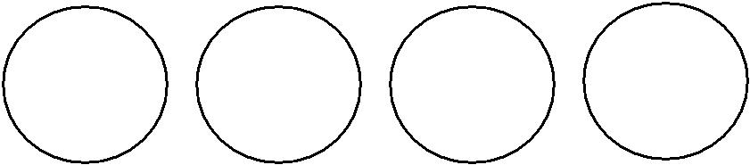

ENGLISH HINDI URDU ARABIC

SOFTWARES

AUTOCAD 3DS MAX

REVIT LUMION

ADOBE PHOTOSHOP ILLUSTRATOR

ADOBE InDESIGN

SKETCHUP

CONTACT DETAILS

Address - Abu Dhabi

Email address – gulfjobseeker-393092@2freemail.com

