CURRICULAM VITA

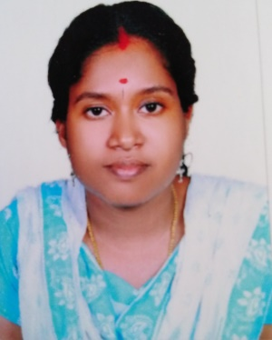

Email : gulfjobseeker-393114@2freemail.com
CARRIER OBJECTIVE
To Play an active role in Contributing the growth of Oraganization by fully utilizing my potential
PERSONAL PROFILE
Date of Birth : 08-09-1988
Sex : Female
Merital Status : Married
Nationality : Indian
Mothertoung : Malayalam
Languages known : English,Malayalam
Hobbies : Reading,Games
EDUCATIONAL QUALIFICATION
Exam Passed | Institutio | Board/University |  | Year
SSLC | govt high school  Uliyanadu | Board of Public exam |  | March2004
Plus Two | S N Trust Higher  Secondary School  Chathannoor | Board of Highersecondary Exam |  | March2006
B Com | S N College Chathannoor | Kerala University | March2010

Other Skills & Knowledge
- M S word
- Excell
- Tally
- Focus
- Photoshop

Working Experience
- Accountant : 2 year (computer center)
- Data entry operator : 1 year (corporation office)
- Tally tutor : 2 year (computer center)
- Accountant : 1 year Sharjah (building material shop)
Declaration
I here by declare that the above mentioned information is true to my knowledge.If I am given an opportunity to take part in your esteemed Organization. I assured that I will be worthwile to fulfil the requirements to your satisfaction

