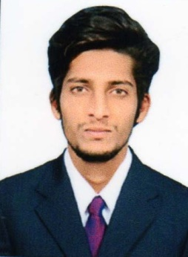
Email : gulfjobseeker-393121@2freemail.com

PROFESSIONAL OBJECTIVE:

To acquire a challenging position in an environment where I can best utilize my skills,education, knowledge and thereby establishing myself as a valuable asset to the organization.

PROFESSIONAL EXPERIENCE:

2 +Years in IT service in sales and customer support. Handling 250+ sales and service requests each month.

Role: Digital Interaction Advisor.

Roles and Responsibilities:
- Responded to Customers in a timely matter via Live Chat.
- Assisted with answering questions and troubleshooting for online opportunities.
- Suggested merchandise, upsell, and assisted with online promotions.
- Contacted shipping carriers for tracking and lost packages.
- Answered inbound phone calls for Cast members and Personal Shoppers.
- Applied Cast member discounts to shipped orders and assisted those who could not apply to their accounts.
- Helped with Guests escalated orders from Personal Shoppers.
- Keep records of customer interactions or transactions, recording details of inquiries, complaints, or comments, as well as actions taken.
- Check to ensure that appropriate changes were made to resolve customers' problems.

EDUCATIONAL QUALIFICATION:

Degree / Certificate | College/School | University/board | Year | Marks Obtained
B.Tech (E.E.E) | Aditya college of engineering  Madanapalle | JNTU  Anantapur | 2015 | 60%
Intermediate | Narayana junior college,kadapa | Board of Intermediate  Education, A.P | 2011 | 76%
SSC (10th) | Pushpagiri high school,kadapa | Board of  Secondary  Education, A.P | 2009 | 75%
.

TECHNICAL SKILLS:

- Programming Languages : Basics in C,Java.
- Operating Systems : Windows family.
- Software package : MS OFFICE.
- IT Skills : Trained in Switching and Routing Networking(CCNA)

INDUSTRIAL VISIT:

- Visited “APGENCO”Power Plant at Srisailam.

PERSONALITY SKILLS:

- Good team player.
- Quick adaptability and eager to learn new things.
- Dedicated to work.
- Ability to work as individual as well as in group.
- Excellent communication skills.
- Strong motivational and leadership skills.

EXTRA CURRICULAR:

- Participated in various seminars during my graduation.
- Volunteered service for “Helping hands” Orphanage camp in collecting and donating stationary to physically challenged children.

PERSONAL INFORMATION:

- Date of Birth : 01-08-1994.
- Gender : Male.
- Marital Status : Single.
- Nationality : Indian.
- Languages known : English, Hindi & Telugu.

ACKNOWLEDGEMENT:

Hereby, I acknowledge that all the information provided in this resume are all true and thanking you in anticipation of your compliance.

