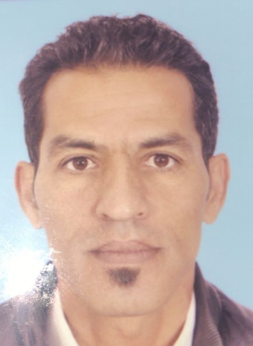
PERSONAL INFORMATION
E-mail: gulfjobseeker-393131@2freemail.com
Visa status: Visit Visa
Language: Arabic, English, French
Nationality: Moroccan

SECURITY GUARD with DPS / SIRA PROFESSIONAL PROFILE PERSONAL SUMMARY
An alert and observant Security who has the ability to ensure that all security matters are well managed and maintained. I have a natural instincts and insight needed to find the best solution to unclear security situations, issues and problems. I can accurately interpret regulations and I have the exact combination of knowledge, skills and abilities that many employers are looking for. During a successful career I have provided highly visible deterrence to lawbreakers and make sure that everyone observes all applicable rules. My key skills lie in my ability to carry out special assignments, with minimal supervision and my insistence that all security procedures and protocols are properly followed. I also have the personal fortitude and integrity needed to take appropriate actions when security deficiencies are identified.

WORKING EXPERIENCE SECURITY GUARD
2017 – 2018 Security Supervisor (Agadir – Morocco)
Responsible for maintaining building security by providing an on-site presence, completing routine patrols and carrying out inside and outside security checks.
Duties:
- Patrolling assigned areas to ensure the protection of visitors, property and equipment.
- Carrying out perimeter checks.
- Assessing the security needs of an emergency situation and then acting accordingly.
- Enforcing rules and regulations.
- Maintaining confidentiality of all security related matters.
- Calmly directing people who cause a disturbance to leave the property.
- Reporting any suspicious activity to the police.
- Checking alarms, locks and fences.
- Restrain people who are causing a disturbance.
- Verifying identification to insure only authorized persons are permitted on the premises.
- Answering queries from members of the public.
- Protecting property from theft, vandalism, or accidental damage.
- Checking fire-fighting equipment on a regular basis.
- Working with confidential information.
- Monitoring and setting building and equipment controls
2009 to 2017 various Security positions and experiences (Security In charge / Supervisor) with G4S morocco
2007 to 2009 Security Guard at Hotel Tafoukt (Agadir – Morocco)
2004 to 2007 Security Guard at Hotel Timoulay (Agadir – Morocco)
2002 to 2004 Security guard at Hotel Tikida Dunas (Agadir- Morocco)
2000 to 2002 Security Guard at Hotel Royal (Agadir – Morocco)

EDUCATIONAL BACKGROUND
* 1998 Diploma of Accounting – Morocco
* 1994 2 years of University of Al Kadi Eyed – Marrakech –Morocco
* 1992 Baccalaureate in modern literature -lycee Iben khaldoun High school – Safi – Morocco
Profession Certificates:
* 2017 - DPS / SIRA Dubai
* security
* FIRST AID
* FIREFIGHTING
*
*

- Ability to assess and evaluate situations effectively.
- Guarding buildings and property.
- Meeting, screening and logging all visitors. Personal
- Ability to function effectively in stressful situations.
- Can work well in a team oriented environment.
- Ability to interact effectively at various social levels and across diverse cultures.

Full Professional Working Proficiency in Arabic, French and English

