CURRICULUM VITAE
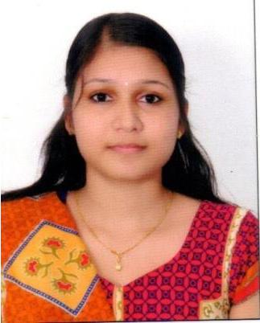

JINSHA

Email: jinsha-393150@2freemail.com

Visa status: Family/Husband

CAREER OBJECTIVES

Looking for an organization where I can utilize skill and creatively involved with system that effectively contributes to the growth of organization.

EXPERIENCE
 |  | (Software developer)
Duration | : | March 2018- Jan 2019
Project | : | Hospital Management System
Description | : | Assist hospitals in managing their work. This system will help different

ways. It will keep track and updating patients and doctors’ records. It will also help in searching for any information related to patient’s history and also this system maintains the entire operations of hospital managements.

Technologies : ASP.NET,MVC, SQL Server, C#, Entity Framework

EDUCATIONAL QUALIFICATION

2015- 2017 : Master of Computer Application

Anna University.

2011- 2014 : Bachelor of Computer Application

Bharathiar University.

SKILLSET

- Operating systems: Windows XP, Windows 7

- Programming Languages: C, Java, Vb.net, c#, Visual Basic

- Web Application: Asp.net, Html, CSS, Java script

- IDE: Eclipse, Net Beans, visual studio

- Databases: Oracle, MySQL, MSSQL Server

PROJECT

Title: Design and implementation of RTO monitoring with safety and security

Duration: 2months

Team Size: single

Technologies: Asp.Net, MySQL server

Description:

- This project is mainly used to manage the RTO Service.

- The purpose of the system is to provide a leading technological tool for the ease of

RTO functions such as registration, learner’s license, changing of address, renewal form and much more. These are the main activities of RTO office.

- It is also decreasing the work pressure and efficiency of the employees.

- To ensure transparency in the day to day management and administration of the officials in the RTO department.

- It is more reliable, accurate, time saving and free from any misuse.

- To provide easiest and efficient way for completion of RTO work.

PERSONAL INFORMATION

Date of Birth | : | 29-07-1993
Gender | : | Female
Nationality | : | Indian
Languages Known: |  | English, Malayalam, Tamil, Hindi

DECLARATION

I hereby declare that all statements made in this application are true, complete and correct to the best of knowledge and belief.

Date: JINSHA

