CURRICULUM VITAE
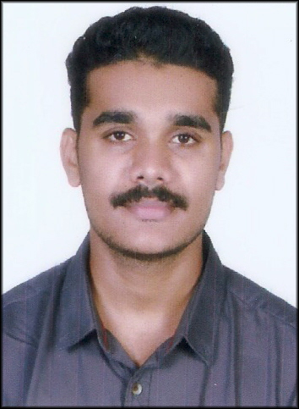
LIBIN

OBJECTIVE

To be involved in a highly competitive environment and to achieve greater heights in life through hard work, real attitude and innovative thinking and I seek challenging opportunities where I can use my skills and ability for the success and growth of the organization.

EDUCATIONAL QUALIFICATION

Education | Board / University | Name of the institution | Year of passing | Percentage of marks (%)
Diploma in Mechanical Engineering | Directorate of Technical Education | SCAD Polytechnic College, Cheranmahadevi , Tirunelveli, Tamilnadu | 2017 | 83%
XII | Kerala State board | P.S.V.P.M.H.S.S , Ayravon , Konni. | 2014 | 71%
SSLC | Kerala State board | REPUBLICAN VOCATIONAL HIGHER SECONDARY SCHOOL, KONNI. | 2012 | 80%

PERSONAL SKILLS

❖ Willing to face challenging tasks and ability to finish the
assignment work in time.
❖ Self driven and a team player

HUMAN SKILLS

❖ Building relationship
❖ Listening skill
❖ Helping nature

training and internships

Undergone Industrial Training at Kerala State Road Transport Corporation (KSRTC), Mavelikara from 11/05/2016 to 21/05/2016.Also undergone 3-months training in Technical Service at Popular Motor World Pvt Ltd (POPULAR HYUNDAI) Kottayam, since 01/07/2017 to 30/08/2017.
experience

Worked as Technical Service Advisor at Kottayam, Kerala since 01/09/2017 to 30/04/2019.

PERSONAL PROFILE

Date of birth : 30/12/1996
Gender : Male
Religion : Christian
Marital status : Single
Nationality : INDIAN
E-mail ID : libin-393191@2freemail.com
Languages known : English, Malayalam , Tamil

DECLARATION

I hereby declare that all the above details are true to the best of my knowledge and belief.

Place :
Date : LIBIN

