CURRICULUM VITAE
Kiran 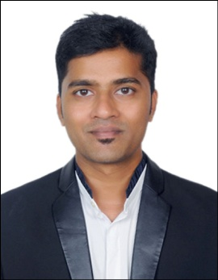

, E-MAIL: kiran-393225@2freemail.com

Career Objective:

To seek a challenging long-term career oriented employment within a reputed organization, to invest all my professional experience and educational qualification to the optimum benefit of the organization and to achieve my goal.

My Strength:

- Strong verbal and personal communication skills.
- Self-motivated and dedicated to the job.
- Quick learner and a team player.

Academic Qualification:

QUALIFICATIONS | INSTITUTE/UNIVERSITY
Masters Of Business Administration (MBA) in Tourism & Operations | Rashtriya Vishwa Vidyapeeth, Mumbai, India
Bachelors of Commerce | Tilak College, Mumbai, India  Mumbai University
Higher Secondary Examination | Tilak College, Mumbai, India  Maharashtra State Board
High School Examination | St. Augustine High School, Mumbai, India  Maharashtra Board
Work Experience:

- Worked as a Sr. Executive.

Duration: 19th Feb’18 till 26th Jun’19.

Job role:

- Working professionally and independently in providing travel services by e-mail or phone to our corporate clients.
- Rebooking clients and reissuing ticket’s on a preferred flight option using Amadeus & Galileo GDS.
- Performing additional job-related duties as assigned by management.
- Managing workflow and process in accordance with SLA.
- Offer best travel options in terms of pricing and routing.
- Processing refund’s in case of any booking cancellation through our in-house application.

- Worked as a Sr. Executive.

Duration: 13th Sept’16 till 6th Feb’18.

Job role:
- Providing on call customer service to passengers who are from European market in regards to their Flight & Hotel reservation.
- Rebooking passengers on a preferred flight using Amadeus & World span GDS in case of flight schedule change or cancellation.
- Making hotel reservation for passengers using in-house application in case of flight disruption.

- Worked as a Sr. Submission officer in Visa and Passport Dept.

Duration: 29th Mar’15 - 31st Mar’16.

Job role:
- Processing Indian Visa and Passport applications in BLS premium lounge and handling customer complaints.

- Worked as a Sr. Executive for US operations.

Duration: 27th May’12 - 2nd Feb’15.

Job role:
- Handling Visa Dept. and attending enquiry calls for Indian Visa.

Additional skills:

- Proficient with MS Word ,Excel, PowerPoint
- Internet and E-mail

Personal Details:

- Date of Birth : 9TH Jan’1991
- Gender : Male
- Marital Status : Unmarried
- Nationality : Indian
- Language Known : English, Hindi, Marathi & Konkani

I hereby declare that all the information furnished above is true to best of my knowledge and belief.

Date: - ------------------------------------------
GOWDA

