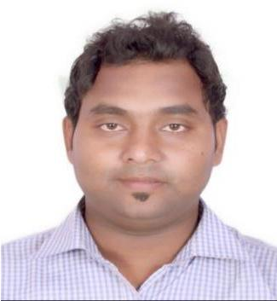
CURRICULUM VITAE

SHOIB
(Civil Engineer)

Email id:- Shoaib-393226@2freemail.com
DUBAI,(UAE).

OBJECTIVE:

Seeking challenging & responsible position to utilize my skills, knowledge and experience in Construction field with a growth-oriented organization.

EXPERIENCE DETAILS:

Designation Duration

: Site Engineer (Execution &Coordination)

: June 2017 to July 2019
High rise Building (Mivan Shuttering /conventional) (Residential Project)
Oberoi Enigma 67 floor consisting of 2 tower and Podium
VDF for Podium and STP for both the towers.

- Key roles and responsibilities as Site Engineer

➢ Study drawings & specification for structure.
➢ Responsible for overall site Execution and completion.
➢ Planning and allocation of work for the workers and also monitor the execution of work. ➢ Responsible for overall site Execution and completion.
➢ Conduct monthly project progress review meeting. ➢ Maintaining all standard procedures of Organization. ➢ Contractor Co-ordination for progress

➢ Ability to multi-task, complete work by understanding the drawing.

Designation Duration

: Site Engineer (Execution &Coordination)

: June 2015 to June 2016 ,June2016 to June 2017
Johnson mathey Chemical plant (Industerial project)

- Key roles and responsibilities as Site Engineer

➢ Study drawings & specification for structure.
➢ Planning and allocation of work for the workers and also monitor the execution of work. ➢ Site execution.
➢ All relevant quality check records at each stage of construction work are created and maintained for future reference.

➢ Co-ordinate with planning team. ➢ Subcontractor billing.
➢ Quality and Safet

ACADEMIC PROJECT:

Project Title: |  |  | Bacterial Concrete(Self-Healing Concrete)
Team Size | : | 4
Year | : | 4th Year (Final Year Project-2017)

Description: No. of concrete cubes had been casted with bacterial solution. As the cracks developed automatically bacteria started healling the cracks.

Learning Opportunity: Concrete Cracks filled by the bacteria (Shewanella sp. , Bacillus Pasturii),

ACADEMIC DETAILS:-

Examination/Degree | School/College | Institute/University | %Scored | Year
BE(Civil) | AnantraoPawar | Pune University |  | 2017
 | College Of |  | 65.33%
 | Engineering
HSC | Tilak College | Maharashtra, Mumbai | 60% | 2011
 |  | Board
SSC | Drivit High School | W.B.B.S.E. | 58% | 2009

KEY SKILLS:

- Team working

- Technical skill

- Manangement skill

COMPUTER SKILLS:
- Microsoft Office (Word, Excel, Power point)

- AutoCAD

PERSONAL DETAILS:-

Current Address | Dubai, UAE
Gender | Male
DOB | 19/02/1993
Marital Status | Unmarried
Languages | English, Hindi, Marathi, Bengali , Urdu,
Hobbies | Listening Music, Watching TV, Surfing Internet etc.
Nationality | Indian

Declaration:
The detail furnished above is correct to the best of my knowledge and understanding.

PLACE:- SIGNATURE:-

