SHAJI

Email:
Shaji-393227@2freemail.com

Personal Data

 | Sex |  |  | : |  | Male
 | Nationality |  |  | : |  | Indian
 | Status |  |  | : |  | Married
Languages Known

English, Arabic, Hindi, Malayalam.

Computer Knowledge Having good knowledge of computerized Accounting

Soft Ware - Tally ERP , Quick book, Point of Sale etc

OBJECTIVE
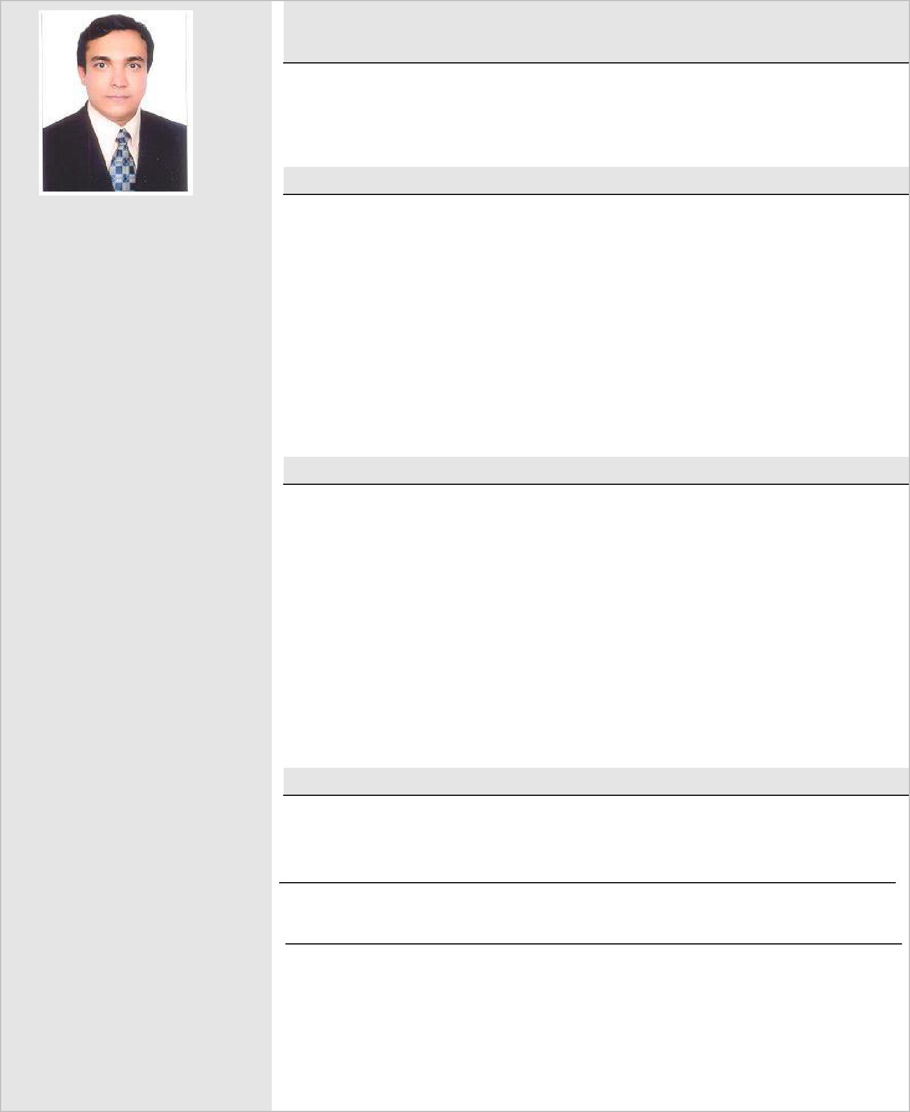

Seeking a suitable and challenging position in a dynamic organization which will utilize my abilities and work experience and to prove my abilities and hard work.

EDUCATIONAL QUALIFICATION

- M.Com course completed from Kerala University
Advanced Financial and Cost Accounting are major subjects
- B.Com from Kerala University
Advanced Accountancy and cost Accountancy are main subjects

- Pre-Degree course from Kerala University Accountancy and commerce were major subjects

- S.S.L.C. from Board of Technical Examinations

ASSETS
- Ability to handle all accounts works independently.

- Punctual and hardworking.

- Ability to work under pressures of deadlines.

- Team player

- Possesses strong analytical and problem solving skills

- Goal oriented and self motivated proactive individual

- Ability to make well thought and timely decisions

- Holding valid UAE Driving License.

- Detail –oriented, efficient and organized professional with extensive experience in accounting systems

- Knowledge of speaking Arabic.

PROFESSIONAL EXPERIENCE
UAE

Finance Manager

From June 2017 to June 2018
.
Senior Accountant March 2010 onwards

- MIS Report to the management on weekly basis.

- Follow up with the bank for the day to day smooth running of financial activities

- Prepared annual sales reports and commission for sales staff.
- Internal auditing and verification of accounts.

- Management of accounts receivables and accounts payables.

- Monthly salary payment through WPS system to employees.

- Meeting cash flow requirements with the regular chasing of clients with the help of the concerned staffs.

- Preparation of bank reconciliation, agents reconciliation and inter branch reconciliation statements.

- Preparation of Trial Balance, P&L ,Balance Sheet & Final
Reports for Auditing Purpose.
.

Sharjah.
Senior Accountant

Dec 2007 to January 2010

dd

- MIS Report to the management on monthly basis.

- Follow up with the bank for the day to day smooth running of financial activities.

- Prepared annual company accounts and reports.

- Internal auditing and verification of accounts.
- Management of accounts receivables and accounts payables.
- Monthly payroll applications verifying.

- Meeting cash flow requirements with the regular chasing of clients with the help of the concerned staffs.

- Preparation of bank reconciliation, agents reconciliation and inter branch reconciliation statements.

- Preparation of Trial Balance, P&L ,Balance Sheet & Final Reports.

Sharjah
Branch Senior Accountant 1999 - 2007

Cla

c

- Keeping day to day record of all the financial transactions.

- Follow up with the bank for the day to day smooth running of financial activities.

- Prepared annual company accounts and reports.
- Authorized signatory for all the financial transactions.

- Management of accounts receivable and accounts payable.
- Computation of sales commission for sales Team and payment on time.

- Meeting cash flow requirements with the regular chasing of clients with the help of the concerned staffs.

- Meeting cash flow requirements with the regular chasing of clients with the help of the concerned staffs.

- Preparation of bank reconciliation, agents reconciliation and inter branch reconciliation statements.

- Monitor company expenses and approval of payments.

Sultanate of Oman

Office Manager cum Accountant | 1990-1998

- Office administration and management
- Looking after Sales of Building Materials, Electrical, Electronics &Hard wares.
- Keeping record of the day to day business activities.
- Follow up of receivable and payables.

- Preparing bank reconciliation statement.

- Reconciliation of receivables and payables and follow up of payments.
- Preparing annual accounts for audit purpose.

- Follow up with the Banks for the day to day smooth running of the financial transactions.

S.V. Surana & Co, Chartered Accountants, Highpoint 4, Bangalore, Karnataka.

Accountant cum Audit Assistant | 1989-1990

- Supporting companies for maintaining of books of accounts for audit purpose
- Assisting the auditing work of the clients.

- Visiting clients for the proper maintaining of books of Accounts.

