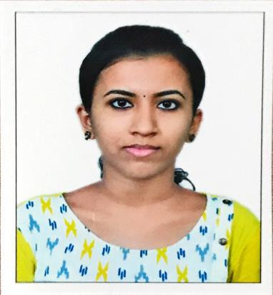

HASHNA

E-mail ID :
Hashna-393239@2freemail.com

CARRIER OBJECTIVE:

To be a part of a company that indulges professional growth which provides challenging growth and rewarding career while allowing me to utilize my knowledge and skills.

Proficiency:
HDL&HVL | :- | Verilog and SystemVerilog
Hardware | :- | Zedboard(ZYNQ System XC7Z020-Verilog CLG484)
Tools | :- | Questasim , Vivado

MAJOR PROJECTS

- VGA CONTROLLER

Designed a VGA controller which is a standard interface for controlling analog monitors. The major blocks of the VGA controller include a clock divider, Horizontal sync generator, Vertical sync generator and RGB generator modules. Designed VGA controller using Verilog and implemented using Zed Board.

- ROUND ROBIN ARBITER

Development of Verification Environment of an using SystemVerilog .The purpose of this project was to build a verification environment for the given Round Robin Arbiter design using SystemVerilog and check for the correct functionality in accordance with the intent specified in the specifications of the device with a resulting 100% Code Coverage and 100% Functional Coverage. Software Tools: QuestaSim.

MINOR PROJECTS

1) LED DRIVER

Developed a Verilog code for Led Driver and implemented it on Zed Board.It consists of an 8x16 ROM structure that is used to drive a row of LEDs on the Zed Board. A clock of 100Mhz is divided, which will drive a counter that addresses the mem module that is already created.

- Synchronous FIFO

The purpose of this project was to build a verification environment for the given Synchronous FIFO using SystemVerilog and check for the correct functionality in accordance with the intent specified in the specifications of the device with a resulting 100% Code Coverage and 100% Functional Coverage. Software Tools: QuestaSim.

EDUCATIONAL QUALIFICATION

BTech in Electronics & Communication (2014-2018)
Higher Secondary Education (2014)

WORK EXPERIENCE

6 months internship

WORKSHOP ATTENDED

- Attended an industrial training based on in “Embedded System Design” from Bitsforge Technologies Pvt Ltd, Kakkanad, Kerala.

- Attended workshop on “Introduction to VLSI Design” by CVC Pvt Ltd,

Bangalore.

LANGUAGES

English , Malayalam , Hindi

STRENGTHS

- Positive thinking
- Self-respecting and Adaptable

- Ability to work in a team

- Good communicational skills

I do hereby confirm that the information given above is true and to the best of my knowledge.

HASHNA

