TUSHAR

CURRICULUM VITAE
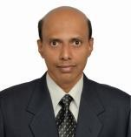

ASSISTANT VICE PRESIDENT

(Banking / Logistics)

Email

Tushar-393262@2freemail.com

2

tushar-393262@2freemail.com

TUSHAR

^{Professional} ^{Profile} PROJECT MANAGEMENT / OPERATIONS MANAGEMENT – Banking
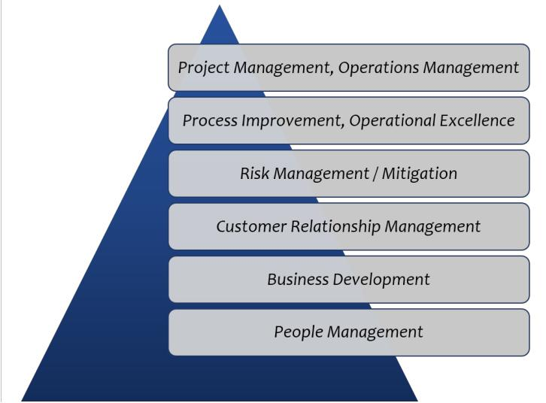

A seasoned banking operations, project management, compliance Skills Pyramid and service quality management professional with over 25 years of

qualitative experience, predominantly in the areas of improving operational process, compliance & end to end project management.

- Instrumental in implementing project management methodologies to manage projects through to completion, within the budget, on time and with superior quality.

- Proficient in quality & communications management, cost management, estimation, risk and change management along with mitigation, support and customer escalations to drive smooth operations across organizations.

- A strategist with proficiency in resource planning and empowering organizations with the tools, technologies, and strategies to bridge business gaps.
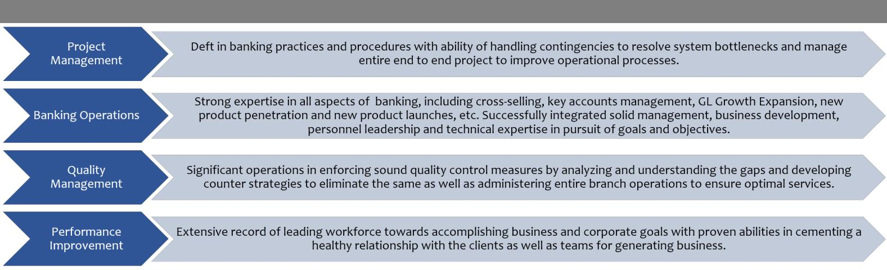

Professional Highlights

Work Experience

Since Feb 2006 in Mumbai

Current designation: Assistant Vice President – Compliance
Reporting to Vice President

Growth Path:

Since Dec 2016 as Assistant Vice President

Jun 2012 to Dec 2016 - Senior Manager

Apr 2008 to Jun 2012 - Manager
Feb 2006 to Apr 2008 - Assistant Manager

The current position is completely responsible for ensuring compliance to all regulatory guidelines issued by various regulators and internal audits issued for Payments Business with minimal critical, revenue leakage and repeat observations.

Highlights / Key Roles

- Ensure compliance to Regulatory guidelines and implementation of policies for Payments Business

- Managing, analyzing & converting the business requirements into functional specifications ensuring deliverables meet organizational and regulatory requirement.

3

- Implementing effective quality control processes, identifying, measuring and mitigating project risks by conducting continuous impact analysis for assessing the consequences of the project deliverables.

- Responsible for driving continuous improvements and establishing all key stakeholders buy-in with overall accountability of defining the clear business cases for all stakeholders.

- Involved in designing / streamlining the workflow of applications for elimination of “Non-value Added” steps and automation of work threads to drive cost benefits.

- Providing integrated reporting & analytics that enable effective business decision making and actionable insights by coordinating and working closely with the stakeholders.

- Strategically improving overall processes by assisting in planning and conducting process improvement workshops as well as implementing the projects.

- Defining performance standards across all functional areas and periodically reviewing performance with the deft application of concurrent management audit procedures.

- Producing project definitions, including validated functional requirements, scope, roles, responsibilities, budgets, timescales and resources by coordinating in overall implementation activities involving stakeholders.

- Responsible for conducting service quality, and business process assessments in the retail liabilities & asset branches.

- Identifying the gaps by analyzing the outcome of service quality and operational process assessments and driving the necessary improvements.

- Creating & sustaining dynamic environment and motivating performance among team members by conducting training / mentoring sessions that fosters the development opportunities.

- Key achievements:
- Awarded Silver Star for implementation of Regulatory guidelines ‘Customer Right’s Policy’ for the bank.

Jan 2000 to Feb 2006 in Mumbai

As Junior Manager – Branch Operations

Accountable for achieving the branch target in current and savings accounts, increased the Bank's profitability by cultivating new business relationships. Implemented competent strategies for boosting the business by penetrating new accounts and expanding existing ones to meet the pre-determined business objectives and targets.

Highlights / Key Roles

- Proactively identified and managed dependencies, potential crises and devised contingency plans, ensuring to improve processes to achieve with immediate delivery.

- Responsible for driving business growth by managing SA / CA & Term Deposits, Cash, Administrative Departments and external sales camps, internal branch operations audits and SOX audits.

- Enhanced customer experience by improving TAT and reviewing the processes in line with regulatory requirements.

- Drove quality improvement initiatives by reviewing SLA’s, monitored performance against key success metrics while identifying and mitigating risks associated.

- Instrumental in streamlining the Branch operations by determining financial objectives, preparing & implementing systems, policies & procedures, thereby improving the overall functioning of processes.

- Managed customer centric branch operations, forwarded customer instructions to the concerned department and achieved delivery and service quality norms by ensuring overall customer satisfaction.

- Managed high net worth clients and oversaw cash, remittances, NEFT, RTGS and MIS units along with inventory management and reconciliation of clearing accounts maintained with the clearing house.

- Key achievement:

- Awarded Silver Award for delivering excellent performance during the Centurion Olympiad 2004 from the Managing Director of Centurion Bank of Punjab Ltd.

4

Preceding Assignments

Aug 1997 to Dec 1999 with Container Movement (Mumbai) Transport Pvt. Ltd.

As Junior Executive - Administration

Nov 1996 to Jun 1997 with Fortress Financial Services Ltd., Mumbai

As Administrative Officer

Jan 1996 to Oct 1996 with KarRox Technologies Ltd., Mumbai

As Administrative Assistant – Education Service

Jan 1994 to Dec 1995 with Citibank (Employed by Rajaram Management Services Ltd.), Mumbai

As Customer Service Executive - Credit Cards Division

IT Skills

- Microsoft Office Packages and Lotus Notes.

Certifications & Courses

2014 Project Management Professional (PMP) Course, Simple Learn

2014 Certified Lean Six Sigma Black Belt, QAI Global Services

2012 Certified Lean Six Sigma Green Belt+, HDFC Bank Limited

1997 Master Diploma in Software Science, Karrox Technologies Ltd

Education Credentials

2000 Diploma in Personnel Management & Industrial Relations, Narsee Monjee Institute of Management Studies, Mumbai

1994 Bachelors in Science, Mumbai University

Personal Details

Date of Birth | : 07th May 1974.
Nationality | : Indian.
Languages | : English, Hindi and Marathi.
Driving License | : Valid Indian Driving License.

