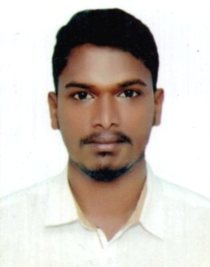

Dickson
Email: Dickson-393266@2freemail.com

OBJECTIVE

Dedicated and dependable Car Driver with excellent record of customer satisfaction. Stickler for punctuality and safety.Established history of completing driving jobs through various kinds of territory at various lengths.

EXPERIENCE
2016-2018
UAE

Taxi Driver
• Safely transport office staff from one place to another on assigned routes
• effectively assist passengers in securing wheelchairs and providing other mobility services
• Ensure appropriate and timely maintenance of vehicles
• Provide customer service to individuals as they reach destination
• Perform vehicle inspection to preventive maintenance
• Make minor repairs as and when necessary

CORE QUALIFICATION
- Thorough knowledge of automobile and equipment safety
- Familiar with routes, locations and addresses in and around UAE
- Ability to work long shifts up to sixteen hours
- High flexibility in scheduling including nights weekends and holidays
- Excellent driving ability even in poor weather conditions
- Good problem-solving and analytical skills
- Strong interpersonal and client service skills

EDUCATION
- Higher secondary education

COMPUTER SKILLS
- DCA ( Diploma in Computer Application)

Driving license
- Valid UAE Driving license : 3671143

personal details
Name : Dickson
Nationality : Indian
Date of Birth : 05-08-1994
Sex : Male
Marital Status : Married
Languages Known : English, Hindi
Visa : Visit Visa

. declaration
I here by declare that the details mentioned above are true and correct in my best of knowledge and belief
Place Diera Dickson

