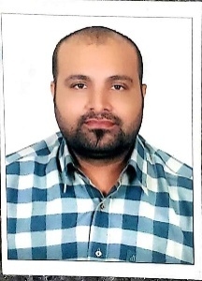
ASIF
Asif-393268@2freemail.com

OBJECTIVE

Seeking a challenging opportunity to demonstrate my skills and abilities and attain experience and knowledge in an organization working on a global scale offering scope for career growth.

SUMMARY

- Possess good interpersonal skills, ready to work within teams and a strong ability to work well under pressure and managing stress.
- Confident, Skillful, team player, proactive decision maker, capable of using own initiative and setting and achieving goals.

WORK EXPERIENCE

Designation : Senior Cab Driver
Duration : 10/Nov/2013 – 20/July/2019 (5 years and 8 months)

ACADEMIC QUALIFICATION

- SSC ( Bajwa Home of Knowledge Secondary School, Rawalpindi) .

PERSONAL SKILLS

Good at;
- Communication
- Team working
- Customer care
- Time management

INTEREST & ACTIVITIES

Movies YouTube
Socializing Travelling
Photography

PERSONAL DETAILS

Date of Birth: 10th-Feb-1984 Place of Birth: Rawalpindi (Pakistan)
Nationality: Pakistani Marital Status: Married
Language: Urdu, Arabic &English Driving License: Manual Driving License(UAE)

REFERENCES: Available on request

