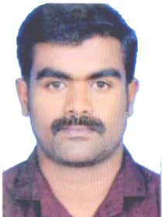

MUHAMMED
Email: muhammed-393269@2freemail.com

DRIVER
■SUMMARY:
Reliable and safety-oriented Driver with 2 years’ hands-on experience in light vehicle driving in UAE . Committed to ensure the safety of passengers,. Excellent communicator who responds quickly in emergency situations. Proven ability to read maps and use GPS systems.
• Familiar with routes, locations and addresses in and around UAE
• Able to perform minor repairs on all kinds of vehicles
• Demonstrated ability to keep the vehicle clean
■LICENSE
Valid UAE Driving License
Issued on: 2016
■DRIVING EXPERIENCE
Driver | DUBAI | 2016-2018
• Safely transport office staff from one place to another on assigned routes
• effectively assist passengers in securing wheelchairs and providing other mobility services
• Ensure appropriate and timely maintenance of vehicles
• Provide customer service to individuals as they reach destination
• Perform vehicle inspection to preventive maintenance
• Make minor repairs as and when necessary
■EDUCATION
High school education (10)

■ PERSONAL DETAILS
Name : Muhammed
Nationality : Indian
Date of Birth : 30-05-1986
Sex : Male
Marital Status ; Married
Languages Known : English, Hindi ,Arabic
Visa : Visit visa
. ■DECLARATION
The above facts are true and correct to the best of my knowledge. I assure you sir, if you give me a chance to work your company that I shall discharge my duties to the satisfaction of my superiors

Diera Muhammed

