ASHISH

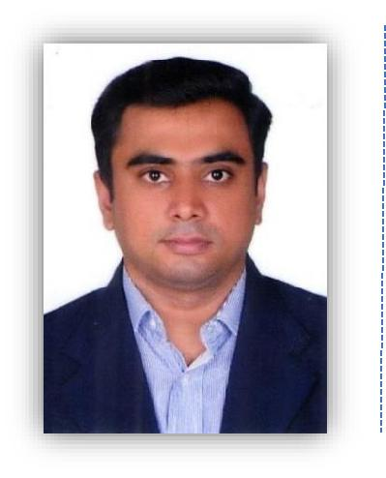

Ashish-393271@2freemail.com

ABOUT ME

“You are never too old to set another goal or to dream a new dream” - C.S. Lewis.

Currently, Proprietor of income tax and finance consultancy firm in Veraval Gujarat. I did my graduation and C.A. articleship simultaneously and after the completion of my articleship I started my own accounting, taxation and finance consultancy firm and continued pursuing C.A. So far, I had cleared till C.A. Final First group. I have also successfully completed CISA exam to step into field of information technology with a certification which is globally recognized for IT Audit, IT Control and security of information systems.

WORK EXPERIENCE

2005 – Till Date

I prepare Credit Management Analysis (CMA) Data and project report for my clients and also assist them in availing working capital loan and term loan for expansion or set up of new business since more than 10 years. I prepare books of accounts for my clients. As a registered tax practitioner, I prepare Income Tax returns of more than 300 clients and appear before income tax authority on client’s behalf as and when needed. I also have experience in conducting statutory audit for small and medium sized firm.

VALUE ADDITION FOR CLIENTS

- Regularly educating clients for Income Tax compliance requirements that helps them save time and energy to focus more on their business and avoid any non-compliances or defaults/penalties.

- Ensuring 100% completeness of finance related documents that has help achieve 30-40 average days from project report submission to approval of finance without compromising integrity.

PROFESSIONAL TRAINING

Three years articleship with Kaushik S. Sheth & Co., Chartered Accountants, Ahmedabad.

Page | 1

ASHISH

SKILLS

- Trained for advanced excel especially useful for data analysis, MIS reporting, various formulas and functions, data cleaning, dashboards, charts etc.
- Familiar with banking process for advances and documentation.

- SAP FICO introduction, basics for end users and consultants, configuration and implementation of FICO module, etc.

- Extensive knowledge of Accounting and Income Tax Software.

- Tally Erp 9

- Working knowledge of Microsoft Office – Word & Power Point.

- M ac Operating System.

EDUCATION PROGRESS

Name of the Course / Certification | Name of the Institution
Certified Information Systems Auditor | Information Systems Audit and Controls
(CISA) | Association (ISACA)
C.A. FINAL GROUP I | Institute of Chartered Accountants of India
 | (ICAI)
B.Com. | Gujarat University

REFERENCE

Available on request

[End of document]

Page | 2

