NIZAR  Email: nizar-393275@2freemail.com | 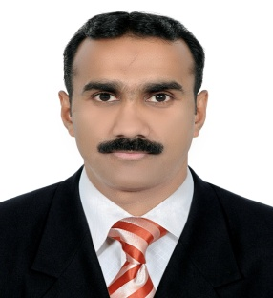  p hoto

CURRICULUM VITAE

CAREER GOALS

To be associated with a professional organization that inspires and brings out the skills of its human resources to an optimum level that leads a definite growth career and to use the best of my knowledge and ability for achieving the targets asset forth. To work in a challenging and friendly atmosphere with ample opportunity for learning, professional development and an opportunity for quantifiable contribution to the organization
PERSONNEL SKILLS

- Good Team Player and excellent in Interpersonal and communication skill.
- Ability to learn and accept responsibility.
- Patience and hard working.
- Punctual and sincere.
- Ability to work in any working conditions.
- High level of confidence, integrity & commitment.
- Excellent communication & interpersonal skills.

- Excellent customer service and administration skills.

EMPLOYMENT HISTORY
- Store Keeper – OS of Oman 2003-2006

- FMCG Supervisor– 2007-To2012

- OFFICE DRIVER & debt collecter- 2012to 2019

- Valid Driving License in UAE(manual)

STRENGTH

- Good Communication Skills. Can act on my own initiative. Proactive, Team player, Optimistic with good listening ability, can deal with all level of personnel.
- Adaptable to different situations & different work atmospheres.
- Ability to learn quickly when facing new problems, a relentless and versatile learner, skilled to analyze both success and failures for clues of improvements.
- Untarnished integrity, dedication to duty and a high sense of loyalty to the organization. Can handle any accounting software with little guidance.

EDUCATION

Degree | Institution | Year of pass
S S L C | St Thomas H S Koorachund | 1990
Pre Degree(+2) | University of Calicut ,Calicut ,India | 1992

PERSONAL INFORMATION

Date of Birth : 10.2.1976
Nationality : Indian
Marital Status : Married
Visa Status : visitvisa
Language Known : English, Malayalam,Thamizh, Arabic Hindi

DECLARATION
I hereby declare that all the information given above is true and correct to the best of my knowledge and belief.

Place: Ajman

Date: NIZAR

