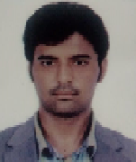

CURRICULUM VITAE

SADDAM

Email: saddam-393330@2freemail.com

Dubai, UAE

Personal Details:

Nationality : Pakistan

Date of Birth : Feb 7th, 1991

Marital Status : Single

Sex : Male

Languages : Urdu, English, Arabic

Visa Status : Employment Visa

Working Experience:
- Working in Aviation since May 2017 to till date.
- Worked as a Delivery man since Jun 2013 to Mar 2017.
- Pakistan: Worked as a Security Guard since Mar 2011 to Apr 2013.

Qualification:

FSc from Govt College Jhelum Punjab Pakistan.

UAE Driving License:

Issue Date : 02/08/2018

Expiry Date : 05/08/2020

Declaration:
I do here by declare that the particulars given above true to the best of my knowledge and belief.
SADDAM

