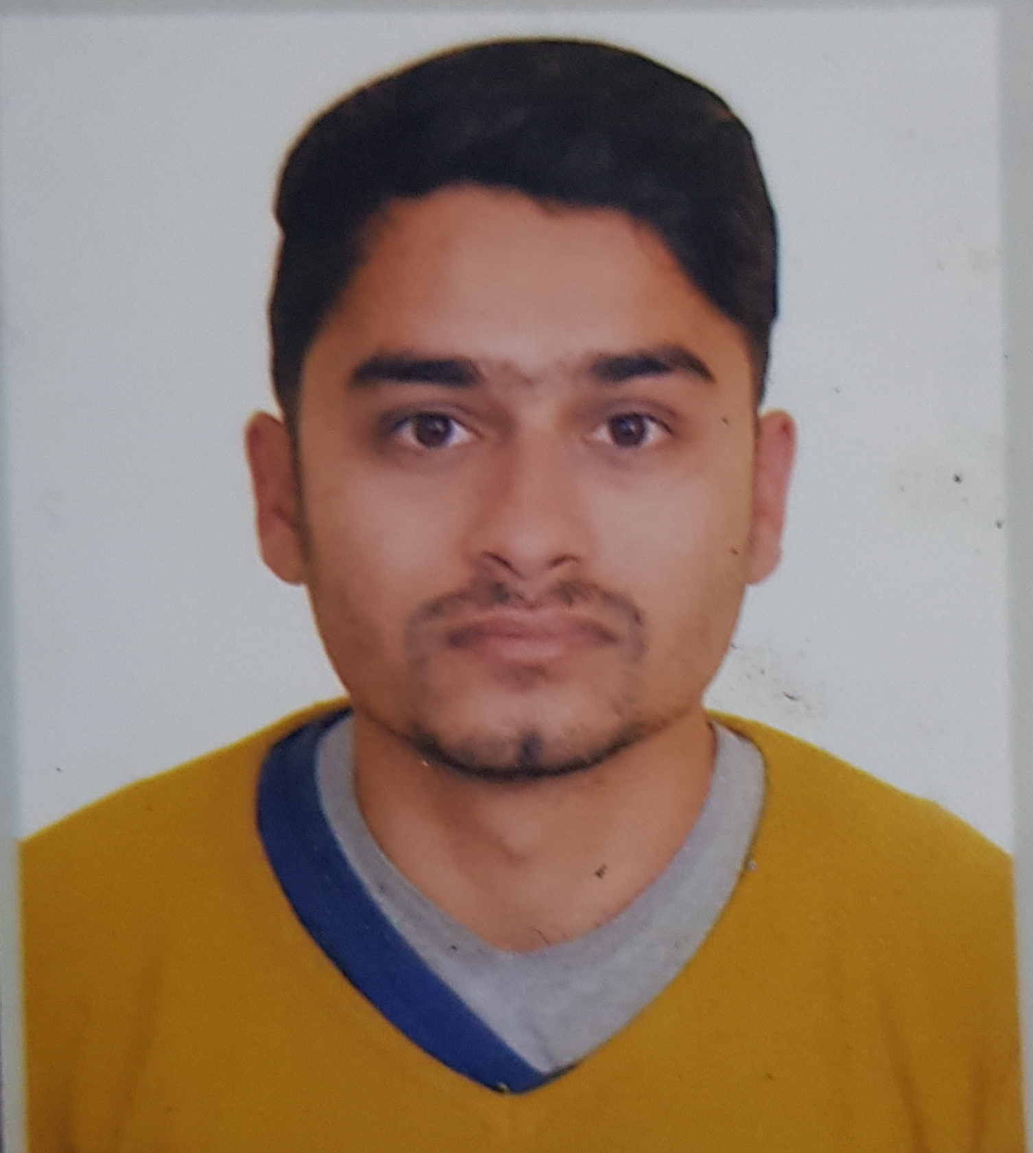
CURRICULUM VITAE

Bharat

E mail: bharat-393334@2freemail.com
________________________________________________________________

CAREER OBJECTIVE
Looking forward to an exciting and challenging career with an organization that has a congenial working environment and provides excellent opportunities for mutual growth and continuously updates my skills.
WORK EXPERIENCE

Sales

Al Ain - UAE  Jan 2017 to July 2019.

Responsibilities

- Welcomes customers by greeting them; offering them assistance.
- Advises customers by providing information on products.
- Helps customer make selections by building customer confidence; offering suggestions and opinions.
- Keeps clientele informed by notifying them of preferred customer sales and future merchandise of potential interest.
- Inventoriedstockandrequisitionednewstockfromsuppliers.

Back Office Executive

Delhi - India  March 2015 to December 2015.

Responsibilities

- Generating Data on Daily Basis,
- Mail Process as per Ground, Coordinate with Local Cable Operators,
- Distributors & Joint Ventures, Send B-mail & OSD to all India subscribers.

Data Entry Operator

Faridabad - India - August 2013 to February 2015

Responsibilities

- Making entries for in/out spare parts.
- Daily reports for required/remaining spare parts in MS Excel by using formulae like Vlookup, Pivot Table etc.

Computer Operator (Back Office Process)
Faridabad - India - October 2011 to July 2013

Responsibilities

- Maintaining students data in MS Excel.
- Coordinate with various universities.

EDUCATIONAL QUALIFICATIONS

Bachelor of Arts from Manav Bharti University (India)

12th from C.B.S.E Board (India).

10th from C.B.S.E Board (India).

COMPUTER SKILLS
- Basic in Computer from Sahni Commercial College, New Delhi, India.

- Typing Speed 40 wpm.

PERSONAL INFORMATION
Date of Birth : 20th Feb 1990
Marital Status : Married
Language Known : Hindi, English, Nepali
Strength : Polite, Straight forward and Self Confident

(Bharat)
Date:
Place:

