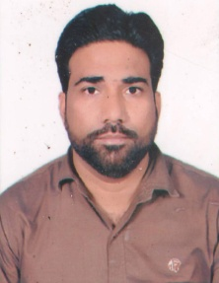
Afzal Date of Birth : 15th May 1979
Sex : Male
Email : afzal-393335@2freemail.com Marital Status : Married
Objective:
Seeking for respective career with international organizations to achieve better opportunity to grow in the career and enhancing personal skills
Profile 1:
I am computer embroidery designer.i have8years experience in Saudi Arabia.
: I have 6 months experience in Qatar.
Skills:
- Preparing the pay roll of various organizations
- Compile analyze and prepare financial records
- Worked exclusively on the tally software to final the account right from the initial stage.
- Managing the data through excel.
- Preparing sales invoices & the upkeep of an accurate accounts filing system.
- Preparation and input of month end journal vouchers.
- Inputting, matching, batching and coding of invoices.
- Debtor and Creditor reconciliations.
- Compile analyze and prepare financial records.
Education:

Intermediate | U.P. Board | 2003
High School | U.P. Board | 1998
Certification/Training:

- Diploma in Computer Application from APTECH COMPUTER EDUCATION BARABANKI (UP).

- Office Packages: MS Word, MS Excel, MS Power Point, MS Acounting.
Language.
English:. Arabic :. Hindi

