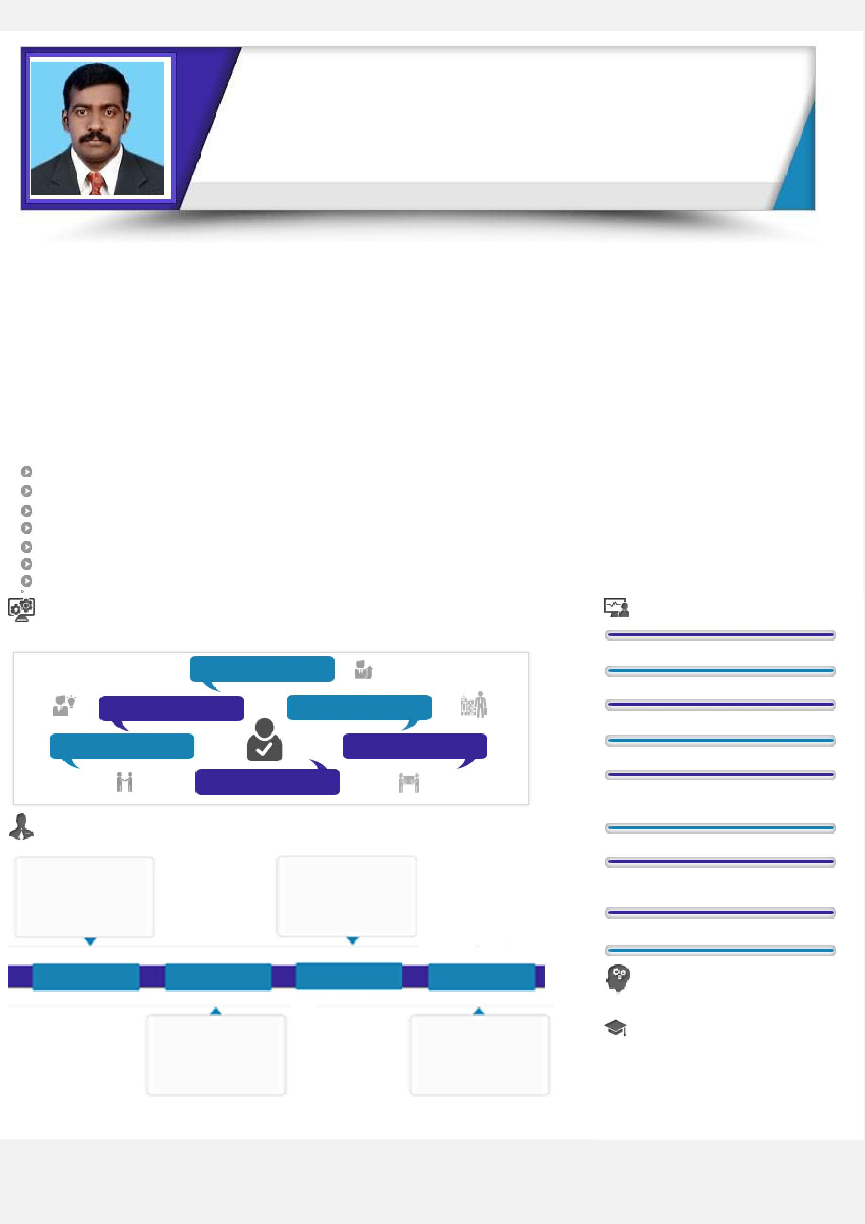
KRISHNA DCE, BE.

Apply for PROJECT ENGINEER (Civil) having 9+ years’ Experience

Seeking a position to utilize my skills and abilities in an Industry that offers professional growth while being resourceful

Krishna-393359@2freemail.com

Summary

Total Experience | : 9+years
Overseas Experience : 5+years
Present Location | : Dubai
Visa Type | : Residence Permit

Degree Certificate Status : Attested for UAE Countries

Notice Period : 1 month

Profile

Done the work within the given Schedule period with challenge.

Ability to live up-to commitments with a sense of urgency.

Self-confidence, optimistic and Punctual in profession,

Ability to establish effective working relationships with coworkers, administration, other departments and the public.

Co-ordination and good relationship with client engineers and co-workers.
Assigning job to the lower level, decision making and solving the problems.

Ability to understand and carry out written instructions to complete assignments.

Soft Skills |  |  |  |  | Key Skills
 |  |  |  |  | Site Execution Work
 | Motivational Leader
 |  |  |  |  | Structure work & Finishing work
Problem solving |  | Interpersonal |  |  | Post Tension &Water proofing work
Collaboration |  | Planner |  |  | Bar Bending Schedule Preparation
 | Communicator
 |  |  |  |  | Quanity Surveying & Sub Contracter
 |  |  |  |  | Bill Verification
Career Timeline |  |  |  |  | Quality Controlling &Cast Controlling
 |  |  |  |  | Proper Utilization of Men, Materials
 |  |  |  |  | And Machineries
Dubai
 |  | Chennai |  |  | Mivan Form work method
Jan’15 – Till Date | May ’14 – Nove’14 | April’11 – April’14 | Apr’07 - Jun’08
 |  |  |  |  | IT Skills
 |  |  |  |  | ➢ AUTOCAD, MS-OFFICESUITE,
 |  |  |  |  | Certificate Course
 | Singapore |  | Nagercoil |  | ➢ BUILDIND CONSTRUCTION
 |  |  |  |  | SAFETY SUPERVISOR
( Singapore)

Work Experience

(Dubai & Algeria)as PROJECT ENGINEER (Jan’15 – Till Date)

Handle Structural and finishing works of Residential + Commercial based High-Rise Building
Handled Structural works and Finishing works of ROVE HOTEL PROJECT (G+9)
Study and work as per both IFC & DM approved drawings and get checking and approval from consultants by providing inspection request before starting of each activity.

Prepare Micro schedule for monthly planning programs with target date and achieve as per.
Measurement Breakup preparing once in a month for Sub-contractors and submitting for final approval to billing department.

Plan every day target and achievement with junior levels on daily basis and distribute proper work to them for the next day.

Co-ordination and good relationship with client engineers and co-workers.
Majorly involved water proofing activities at basement level in present project and Post Tension Slab works.
Managing Multi Cultural man power and utilizes them in a proper way of planning to get profitable output.

Examine the quality of finishing works and execute as per client requirement.

(Singapore) as PROJECT ENGINEER (May ’14– Nove’14)

Sub-Contractor bill checking and submitting to accounts for payment process.
Preparing Bar Bending Schedule and get approval from clients for execution.
Monitoring the Stock and consumption every day of major materials.

Chennai As Engineer Civil (Apr’11 – Apri’14)

Handling the project on progress, sales and cost.

Preparing catch up schedule for achieving the progress and sales.
Handling the project, the as per the Zero Cost.
Cost Effectiveness in the project.

Proper utilization of Men, Material and Machineries.
Maintain records on delay, cash flow, progress, constraints etc.,
Preparing client bill and sub contract bill for the project.

Maintain Quality, Safety and Quantity in the project.
Handling the project on progress, sales and cost.
Preparing catch up schedule for achieving the progress and sales.

JRJ FOUNDATION , Nager coil as SITE SUPERVISOR (April ’07 – June 08)

Setting out of work(Marking)
Bar bending schedule.
Estimating and Costing &Land Surveying.

Education

BE in Civil Engineering from The Rajaa’s Engineering college ,Vadakkankulam with 76% in 2011 (Regular)
Diploma in Civil Engineering from N.M.S. Kamaraj Polytechnic College, Nagercoil with 83% in 2007 (Regular)

Higher Secondary (Draughman civil ) G.H.S. School ,Agasteeswaram with 82 % in 2005 (Regular)

Languages Known

Read : English, Tamil

Write : English, Tamil

Speak : English, Hindi, Arabic, Tamil, Malayalam, Kannada.

Personal Details

Date of Birth : 02/12/1987

Marital Status : Un Married, Age : 31

Declaration I do hereby that all my statements made in this application are true, complete and correct to the best of my knowledge and belief.

KRISHNA

