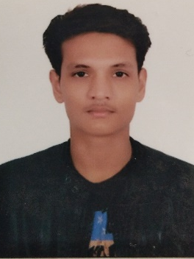
RAGHVENDRA

Recent 12th (Senior Secondary) completed in Arts and now looking for a job also I am a hardworking person and fast learner. So, Any Job Suitable For me.

Education
2016 Higher Secondary in All Subjects, National Institute of open school,
Noida, INDIA (54.8% or 3 GPA)
2018 Senior Secondary In Arts, National Institute of open school,
Noida, INDIA (59% or 3.5 GPA)

Work Experience
- 2015- I worked In Delhi as a Field worker for there need only 3 days.
- 2017- I worked In Haryana as a CSR ( Customer Sale Representative For 1 month.

Personal Info

Date Of Birth
27/11/1997
Marital Status
Single

Skills
Microsoft Office Word
Excellent
Microsoft Office Powerpoint
Excellent
Microsoft Office Excel
Beginner

Languages

English
Billingual

Other Personal Info

Driving Licence – I have but not international only national
Date Of Birth- 27/11/1997
Race- Brahmin
Religion- Hindu
Marital Status- Single
Email Id:- raghvendra-393381@2freemail.com

