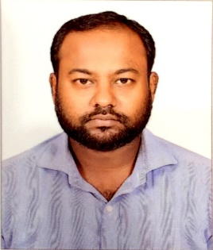
RESUME
ABDUL
Email: abdul-393383@2freemail.com

Applying for the Post of Driver

Career Objective:

To be a dedicated and hardworking professional willing to be a part of a team which dynamically work towards the growth of the organization that gives me the scope to update my knowledge and skills in accordance with the latest technologies.

Experience Profile

Nov 2007 – Nov 2013

Organization: in Saudi Arabia (KSA)

Designation: Lead Salesman (SDP Trainee Supervisor)

Jobs handling:

- Welcomes customers by greeting them; assisting them.
- Directs customers by escorting them to racks and counters; suggesting items.
- Advises customers by providing information on products.
- Helps customer make selections by building customer confidence; offering suggestions and opinions.
- Documents sale by creating or updating customer profile records.
- Processes payments by totalling purchases; processing checks, cash, and store or other credit cards.
- Contributes to team effort by accomplishing related results as needed.
- Keeping in contact with existing customers in person and by phone
- Making appointments with and meeting new customers
- Agreeing sales, prices, contracts and payments
- Meeting sales targets, Giving feedback on sales trends
- Promoting new products and any special deals
- Advising customers about delivery schedules and after-sales service
- Recording orders and sending details to the sales office

Jan 2016 – Dec 2018
Organization: in Abu Dhabi
Designation: Laboratory technician cum driver

Jobs Handling;
- Collection of samples such as oil, water and waste water from various sites
- Meeting with clients and scheduling for sample collection.
- Arrangements of vehicles for sample collection.
- Preparations of sampling kits such as cool box, instruments box
- Calibration of instruments like PH meter conductivity meter and chlorine meter.
- Preparing the chain of custody log on daily basis
- Receiving of samples from clients which are delivering on daily to the lab.
- Helping the chemists, secretaries, or other administrative assistants in performing their duties.

Educational Qualification
- Higher Secondary Passed in 2001
- ITI, welder.
Additional Qualification
- Dubai manual driving licence
- Saudi Arabia manual driving license,
- Typing skills, basic computer.

Personal Dossier

Date of Birth : 23.12.1983
Nationality : Indian
Marital Status : Married
Languages Known : English, Arabic, Hindi, Tamil, Malayalam.

Declaration

I hereby declare that all the above information is correct to my knowledge,

References available upon request!

Abdul

