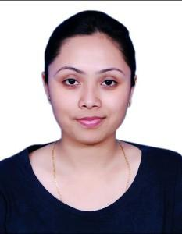
Pratibha

Eligibility ID

Pratibha-393399@2freemail.com

CAREER OBJECTIVE

I am seeking an opportunity in a hospital with a challenging position where I can use my experience, education, medical profession and practical experience to be fully utilized to help the company meet and surpass its goals.

EXPERIENCE

Mar 2018 to Mar 2019

Emergency Staff Nurse Handling emergency patients

Feb 2017 to Mar 2018

Clinic Nurse Attending and assisting in all outdoor gynecological procedures

EDUCATION

Degree/Course | Institute/College | University/Board | Percentage/CGPA |  | Year of Passing
 | Hosmat Hospital | Ragiv Gandhi Uni-
Bsc Nursing |  | versity Of Health | 75% |  | 2012
 | College Of Nursing
 |  | Sciences Karnataka
HSLC | Seven Set Annexe | MBOSE | 56% |  | 2012
 | St. Margaret's
Matriculation | Higher Secondary | MBOSE | 66% |  | 2010
 | School

ACHIEVEMENT

Bls basic life support achieved from ANA

Basic Computer I have knowledge regarding basic computer which is certified

HOBBIES

Reading And Singing

PERSONAL DETAILS

Date of Birth

06/05/1993

Gender

Female

Nationality

UAE

Marital Status

Married

Language Know

English,hindi,khasi,nepali

DECLARATION

I hereby declare that I have 2 years of experience. A year in clinic and a year in hospital. Looking forward for a positive response from your esteem organization.

Pratibha

