SANIKA
P H O T O G R A P H E R

MORE ABOUT ME
Hi! I'm a 23 year old professional photographer from Dubai with over five years of corporate as well as freelancing experience in photographic and marketing processes .
PROFESSIONAL SKILLS

- Photography
- Adobe Creative Suite
- Editing and retouching
- Works well both individually and in a team
  - Can work under pressure
- Can work with tight deadlines

LET'S COLLABORATE!

Email: sanika-393402@gulfjobseeker.com

PERSONAL INTERESTS
Video and Photography Motocross and Track Racing
Long Rides and Cross Country Rides Traveling and Backpacking Camping and Hiking
Making Music and Jamming

PAST EXPERIENCE
Head Photographer
(November 2019- April 2020)
I worked with my team to curate required images to advertise restaurant menus on website/app
Ensured proper workflow of the project
Built promotional video/photo campaigns for social media.
Executed all photo shoots, editing and retouching required thereafter. I have experience in coordinating with different teams for efficiency of product deliverables.
Ensuring completion of multiple client product shoots on time

Photographer/Videographer
Eram Galleria (December 2018 - October 2019)
I worked with the Creatives Team to fulfil clients' needs. I shot products, events, and models, and looked over all the editing needs.
Handled cranes and gimbals for video production Shot and edited teasers, short films.
Worked with government agencies such as Dubai Public Prosecution, Emirates Transport, Dubai Police and Dubai World Trade Center.

PREVIOUS EDUCATION
Symbiosis School of Photography (Pune, India)
Bachelor of Arts in Photography, 2014 - 2018

I specialized in Automobile photography and Photojournalism.

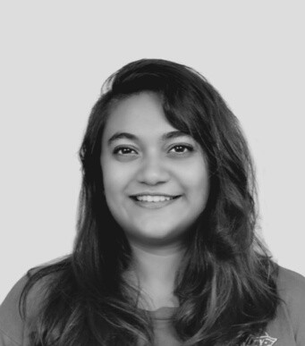
Tilak Jr. College (Navi Mumbai, India)
Science (2012-2014)

Passed first class with Physics, Chemistry, Math and Biology.

