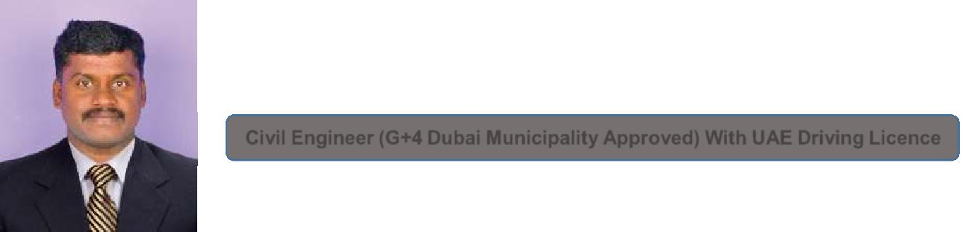
ANTONY DCE, BE.

E-mail: antony-393417@2freemail.com

Civil Engineer (G+4 Dubai Municipality Approved) With UAE Driving Licence

Position apply for Project Engineer

Bachelor Degree and diploma in Civil Engineering, 8+ years work experience in Residential and commercial Buildings as a Civil Engineer.

Having 4+ years UAE experience. I am an Approval Engineer for G+4 Building by Dubai Municipality with UAE driving licence and a member of Society of Engineers Association in UAE.

OBJECTIVE

To be associated with organization that provides me an opportunity to prove my skills and improve my knowledge with latest trends and to be a part of the team that work dynamically towards the growth of the organization.

PROFESSIONAL SUMMARY

Employer

: Dubai, UAE.

Designation

: Civil Engineer.

Period

: Feb 2109 to till date.

Projects Handled :-

G+4, Labour camp project in in Muhaisnah 2, Dubai. Consultant: Em Square engineering consultant. Client: Italco International.

G+M warehouse and office building at Jebal Ali Consultant: Em Square engineering consultant.
Block work, Plaster work at The circle mall project site at JVC, Dubai.

Block work, plaster, tiles, marbles and painting works at Rich Reit Tower project at

Employer | : Dubai, UAE.
Designation | : | Civil Engineer.
Period | : | Feb 2015 to Jan 2019.

Projects Handled :-

Handled G+2, 10 No’s of Township Luxury villas, JVC, Dubai, UAE. (18 million DHS value), OBE Consultant.

Worked at ROVE HOTEL project B+G+M+6+R in Dubai Marina.

Worked at B+G+M+18+R High rise ROVE star Hotel project in Shapoorji Pallonji Middle East project.

Handled G+4+R commercial Building at Deira, Dubai.

G+4 commercial and official Building at Al Muteena, Dubai, UAE. Under HMB engineering consultant.

B+G+4 commercial and Residential Building at Al Buteen, Dubai, UAE.

B+G+1 luxury villa at PALM JUMEIRA, Dubai.

Projects Handled :-

G+M, new warehouse building, and landscaping and asphalt works for DEAL logistics, Jebal Ali, Dubai.

G+M warehouse and office building at RSA logistics, DWC, JAFZA.

Landscaping earthwork, soil cutting, filling and levelling for RSA logistics in DWC, JAFZA.

Employer | : M/s Tarapore and Company Engineers and Contractors, Chennai, India.
Designation | : | Civil Engineer.
Period | : | May 2013 to Feb 2015.

Projects Handled :-

G+1, 148 No’s of luxury Villas, White Meadow, Bangalore, India. G+1, 22 Nos of Silver Springs luxury Villas, Chennai, India.

Employer | : M/s NAPC Ltd, Chennai, India.
Designation | : | Civil Engineer.
Period | : | Jan 2012 to April 2013.

Projects Handled :-

Paint shop, Toyota Kirloskar Motor Pvt Ltd, Bangalore, India

G+1 Warehouse building, TYCO Electronics connectivity India Ltd, Bangalore, India. Levelling, cutting and filling and land development work.

Employer | : M/s L & T Ltd (ECC Division), Coimbatore, India.
Designation | : | Trainee Site Engineer.
Period | : | June 2011 to Dec2011.

Projects Handled :-

G+4 Multispecialty ESIC Hospital Building, Coimbatore. Emergency ward and outpatient ward building in ESIC.

JOB RESPONSIBILITES

Obtaining Building Permits from DM, RTA, and DCD & DEWA. Quantity surveying for tender documents.

Team player and quick learner.

Building material selection and procurement. Standardizing BOQ as per concept.

Short listing, nominating and co-coordinating with a range of professionals, including consultants and contractors/ sub-contractors, to ensure that the project is successfully completed.

To co-ordinate with internal departments.

Commercial and technical negotiations with nominated consultants and contractors

Organizing regular progress meetings and producing status report- including budgeting to the company’s chairman and relevant third parties.

Maintain and enforce excellent construction standards and quality control

Strong planning and organization skills, with the ability to work towards deadlines and manage time effectively.

Preparing primary scope of work.

Reviewing Civil Works & MEP Drawings.

Coordination with architects, consultants, MEP team and sub-contractors etc.

Dealing skilfully with diverse range of people including clients, architects, other engineering professionals, sub-contractors and members.

Estimate quantities and cost of materials equipment and labours to determine project feasibility. Taking responsibility for health and safety on site.

Ensuring quality of workmanship.

Preparing Weekly & Monthly Material & Resources Requirement.

Coordinate with site inspectors to check the ongoing project status and development. Direct the construction operations and maintenance activities at project site.

ACADEMIC QUALIFICATION

Bachelor degree in Civil Engg. : The Rajas Engineering College-Tirunelveli, India – April 2011 Affiliated to Anna University Chennai,

Diploma in Civil Engg. : Government Polytechnic College, Tuticorin. India – March 2008.

SOFTWARE SKILLS

MS Office, MS project, Auto CAD

PERSONAL DETAILS
Date of Birth | : | 12.05.1987
Gender | : | Male
Marital Status | : | Married
Language known | : | English, Tamil, Hindi, Malayalam.
PASSPORT DETAILS
Current salary: |  | 8000.00 per month
Expected Salary: |  | 10000.00 per month
Notice Period: |  | Immediate join

No. of years of total experience as project engineer: 4years 6 months

No. of years of experience working at project site: 8 years 4 months

DECLARATION

I hereby declare that the above information is true to the best of my knowledge. If I get a chance to serve in your organization, I would prove myself and would serve my level best for the growth of the organization.

Date:

Place: Dubai. (ANTONY)

