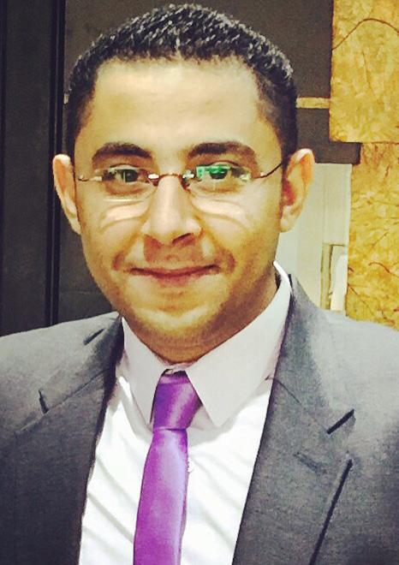
Mario

- ail: Mario-393428@2freemail.com

Objective:

To build a challenging career, gain experience; maximize interpersonal skills in firms that have certain, identified and clear concepts.

Education:

Faculty of Law

Major Helwan University, Cairo-Egypt.

WORK EXPERINCE:

(ABUDHABI-UAE)

(DECEMBER 2017 – May 2019)

Job Title: Showroom Manager

Job Responsibilities:

- Maximizing profitability and setting/meeting sales target, including motivating staff to do so.
- Recruiting, Training Supervising and Appraising Staff.
- Dealing with customer queries and complaints.
- Liaising with Head office reporting (KPI, DTS, Performance and Schedule).

- Responsible for Retail Selling.

(Dubai- UAE)

(July 2015 – July 2017)

Job Title: Sales Executive

Job Title: Assistant Manager

Job Title: Showroom Manager

Job Responsibilities:

- Handle all the customer and market needs
- Track the special orders in the work-shop and check the quality of the products and check the proceed erasure on the right way.

- Responsible for training for the new staff for the jewelry information general and Diamond knowledge especial.

- Manage the sales team towards the target and customer satisfaction.
- Motivate the sales team to add more skills and always follow up them with the latest in the section.
- Providing a superior Customer Service and maintaining a healthy relationship with clients.
- Do the proper daily accounting transactions related to daily sales.

(Cairo-Egypt)
(May 2012 – May 2015)

Job Title: Showroom Manager

Job Responsibilities:

- Do all accounting transactions related to sales

- Do all accounting transactions related to employee salaries and sales commissions.

- Liaison with media and advertising.
- Doing all the sales activities.
- Responsible for Retail Selling.
- Marketing and purchasing for Diamond and Jewelry.
- Collecting more Customers and supplier.

Botros Jewelry
(Cairo-Egypt) (Apr.

2003-April 2012)

Job Title: Retail Sales Supervisor.

Job Responsibilities:

- Responsible for diamond and Jewelry Retail sales and auditing all the Transactions related to retail department and handling all the facilities for Customers.
- Responsible for filming and jewelry dressing in shooting.
- Conduct market research to determine market requirements for existing and future products.

- Providing a superior Customer Service and maintaining a healthy relationship with clients.
- Organize jewelry Fairs with famous Jewelers in Egypt.

Language:

- Arabic: Mother tongue

- English :Flaunt

Computer Skills:

- Knowledge and experience of Windows XP, Microsoft office

Personal Data:

- Date of Birth: May 05 .1986

- Place of Birth: Egypt.
- Marital Status: Single.

- Visa Status: Visit Visa Til (OCT 2019)

COURSES:

- HRD.

- IDL.
- ART OF SELLING (EGYPT – DUBAI).

Key Competencies:

- Excellent written and verbal communication skills.

- Have an Excellent knowledge of GEMS and Diamond.

- Self-motivated and good team leader.
- Organization and planning.
- Problem analysis and problem-solving.

- Formal presentation skills.
- Persuasiveness.

- Adaptability.
- Innovation.
- Judgment.

References available up on request

