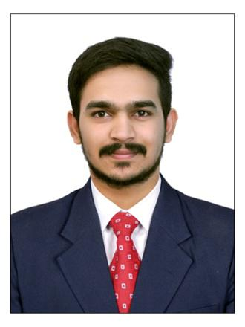
SAI

Sai-393438@2freemail.com

PROFESSIONAL SUMMARY

Results-oriented software engineering professional with 1 year 5 Months of experience in the SAP Area. Worked as SAP MM and SAP PM consultant.

SKILLS

 | SAP MM |  | Good Communication
 | SAP PM |  | Work Under Pressure
 | Knowledge in C language |  | Adaptability
 | Service Now tool |  | Team Member
 | MS Office |  | Flexible
 |  |  | Time Management
 | Technical support

WORK HISTORY

Application Development Associate | Hyderabad, Telangana. [Nov 2017-Mar 2019]

- Collaborated with developers to identify bugs in the system.

- Good Idea about Procure to pay cycle.

- Regular calls and meetings with clients to establish problem specifications and system designs.

- Validations on PO Creation or Change.

- Subcontracting Form for Semi Finished Goods.

- Validations on PR Creation.

- Involved in Patching activity for Development and Quality systems.

- Worked closely with Supervisor and Team Lead to efficiently resolve issues.

- Handled Charm Tool for TR creation.

- Plant Maintenance organization structure.

- Involved in some SAP Project Systems and SAP Production Planning configurations.

- Printer configurations in Plant maintenance Area.

- Group discussions on critical issues.

- Preparation of Test Cases for SME's Review.

- Collaboration with other team members

ACADEMIC QUALIFICATIONS

- 2017 B.E. (Bachelor of Engineering) in Mechanical Department from MVSR Engineering College, Osmania University, Hyderabad (70%)

- 2013 INTERMEDIATE in MPC from SRI CHAITANYA JR COLLEGE, Hyderabad (93.9%)

- 2011 SSC from Mount Carmel High school, Jagitial (89.5%)

ACADEMIC PROJECT

Project Name: Design and Analysis of U-Tube Heat Exchanger Using CFD
Role in project: Designer

Software Used: Solid Works, Analysis

Project Duration: 8 months

Project Description:

- Design of the U-Shaped tube in Solid Works software and applied in CFD Analysis.

- U-Tube Heat Exchanger Experiment.

- Comparison of Practical and theoretical Heat Transfer Coefficient values.

- Inserted the longitudinal and twisted tapes(Insertions) into the pipe to understand the flow

and effect of the Heat Transfer Coefficient.

- CFD results show higher HTC compared to practical results.

- Insertions HTC results are higher than plain tube HTC.

- In Insertions, longitudinal tapes shows higher values than twisted tapes.

CO-CURRICULAR ACTIVITIES & ACHIEVEMENTS

- Client and Customer Award at Accenture for outstanding contributing to Client's Business outcomes.

- Member of CARE India Solutions for Sustainable Development.

- Diploma Certification in AutoCAD.

- Participated and secured 93% in District level Talent Test.

- District level player in Cricket.

- Organized the events and outings in the project.

- Finalist in Foosball game at Accenture internal competitions.

LANGUAGES

- English

- Hindi

- Telugu

INTERESTS

- Travelling

- Trekking

- Cricket

