CURRICULUM VITAE

Jijo
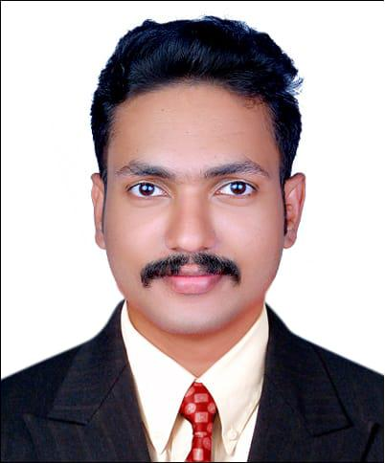

Email: jijo-393448@2freemail.com

OBJECTIVE:

To be a part of an organization where I can fully utilize my skills and make a significant contribution to the success of the employer and at the same time my individual growth

ACADEMIC PROFILE:

Qualification | College/Scho | Board/Universit | Year of | Percentage&cgp
 | ol | y | passing | a
B.E(MECHANICA | Immanuel | Anna University | 2013201 | 6.7
L ENGG) | Arasar JJ |  | 7
 | College Of
 | Engineering
HSC | Gov H S S, | Kerala State | 2013 | 76%
 | Karukone | Board
SSLC | Gov H S S, | Kerala State | 2011 | 80%
 | Anchal west | Board

PROJECT EXPERIENCE :

Mini Project: Design and Fabrication of Hand Clutch System

Main Project: Conversion Of Calciner From Furnace Oil To LPG Firing

System- TTPP (Travancore Titanium Power Plant)

WORK EXPERIENCE:

- Navi Mumbai

Mechanical Supervisor ( 15.06.2017 - 30.06.2018 )

Site contract (NTPC Ltd) –Fabrication ,Erection of piping and structures of the Project

- Chennai

NDT Inspector (04/07/2018 – 01/06/2019) (MPT, VI, UT)

TECHNICAL QUALIFICATION:

QA/QC

Welding inspection

Piping and Pipeline Engineering NDT ( RT, UT,LPT,MPT,VI )

SOFTWARE KNOWLEDGE:

Basic knowledge in Auto CAD ,Pro E and ANSYS

Operating systems: Windows8,Windows7,Windows Vista& Windows XP

PC Packages: MS Power point, MS Excel & MS world

PERSONAL TRAIT:

I am Empathetic and self- motivated, I can communicate reasonably well. I have a good level of emotional intelligence to get along with different types of situations and colleagues. I keep myself cool in hard times and good

AREA OF INTEREST:

Manufacturing Technology Auto Mobile

ACHIVEMENTS AND ACTIVITIES:

Won prizes in intra-college symposium programs

Won prizes for the different sports at H S S School level Completed 1 week soft skill training from IAJJCE
Active participant of science club & Active blood donor

PERSIONAL DETAILS:
Date of birth | 27-12-1994
Gender | Male
Marital Status | Unmarried
Nationality | Indian
Linguistic ability | English, Malayalam, Tamil

DECLARATON:

I hereby declare that all the information furnished above is true to the best of my knowledge and belief.

JIJO Date:

