CURRICULUM VITAE
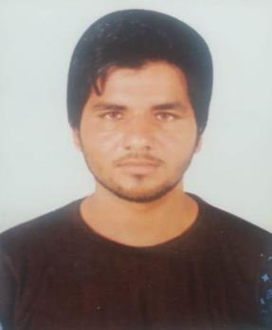

SUNIL

Email : sunil-393449@2freemail.com

OBJECTIVE:
To be part of professional organization and work in challenging environment, which offers an opportunity to grow, develop and contribute to the growth of the organization.

PERSONAL DETAILS

Name | : SUNIL
Date of Birth | : 10/10/1989
Nationality | : India
Sex | : Male
Marital Status | : Single
Visa Status | : Visit Visa

LANGUAGES KNOWN

English and Hindi

EDUCATIONAL QUALIFICATION

Secondary School

DRIVING LICENSE DETAILS

Issued Date | : 22-02-2018
Expiry Date | : 21-02-2020
Issued Place | : Sharjah
PERSONAL SKILLS
Positive attitude and strong sense of responsibility

Ability to work under pressure in fast paced environment and manage multiple tasks .

Dynamic and easily adaptable

Eager to learn and open for further development

EXPERIENCE
1years Driver Experience in Dubai and Sharjah

DECLARATION
If given an opportunity, I shall perform to the best of my knowledge and here by declare that above information is true and correct to the best of my knowledge.

SUNIL

