Baligh

Date and Place of Birth:

Countryside of Taiz City

(31/12/1988)

Contact –Mail

baligh-393468@2freemail.com
Marital Status

Married With Four Children

Languages

Hobbies

The executive project :-

in communication about The Multicast

Transmission Antennas ,And The Multicast Receiption Antennas , for Signals in Communication and internet Techique MIMO - Mymoh (Multi-input , Multi-output ) , and Emulated by MATLAB Program.

Professional Training
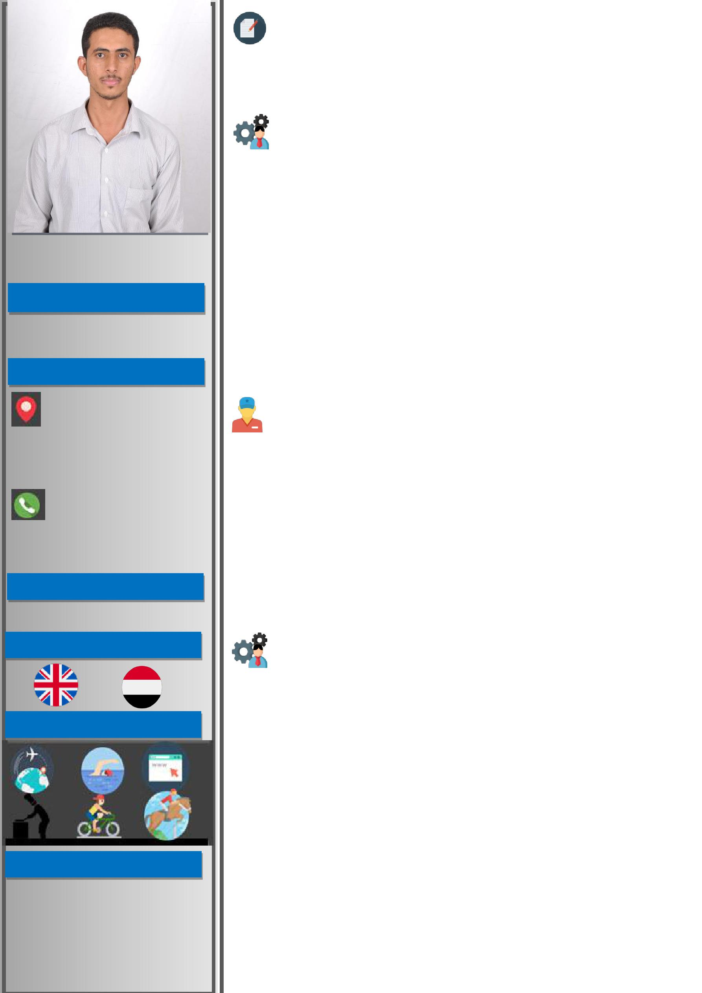

2007 – 2013 : Bachelor's degree

- Specialist : Communication Engineering and Computer, Taiz University – Faculty of Engineering & IT

Professional Experience

- Driving Computer With High Competence.

- Dealing with texts processing Microsoft Office (MS).

- a High Speed Working in Data Entry .

- The Ability to Print ( Arabic – English) with Enough Speed.

- Dealing with Photoshop Program with Great Skill.

- Design, Maintenance and Management Internet Cafe Networks.

- LAN Network and Camera Network .

- Setting up and Programming Wireless Networks.

- Volunteer in Village Cooperative Council in 2017.

Further Education and Training :-

- 2006-2007 : Training Courses in Computer Driving .

- 2007-2008 : English Training untill Upper Intermedite.

- 2012 : Training Course in Menouffiah University , EGYPT REPUBLIC IN ( Antenna ,Satellite ,Mobile Communication .

- 2013 : Training Course in MDF System , Transmission Mw System Village Communication System , CDMA System .

- 2018 – 2019 : Marketing Representative in Golden Company For Advertising and Marketting- Sanaa.

-The Skills and Abilities :-

- Working on computer to long period with all Programmes.

- Very Very Good to Ability to English Language , Reading , Writing And Speaking.

- Ability to work with a high Level of flexibility,Accuracy and Integrity and to work under pressure.

- Ability to pay attention to details and to work with unerring accuracy.

- a High Speed Working in Data Entry .

- Respect the Work and Appointments.

- Excellent Communication Skills .

- Ability To work with sense of responsibility.

- Computer Maintenance Programatically ,Protection and Backup.

- Ability to work and learn at the same time.

- Setting up ideas that are to the work's advantage.

1 of 1

