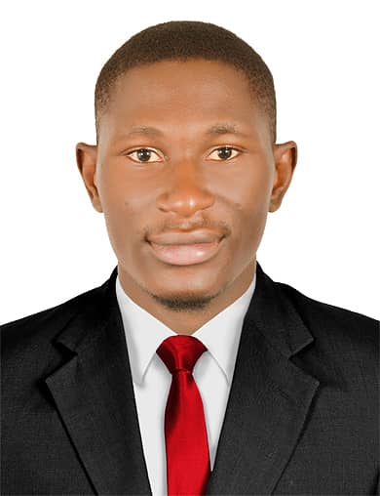
Name THOMPSON
Email : Thompson-393478@2freemail.com
Address : Dubai, UAE
POST APPLYING FOR SALES
____________________________________________________________________________________
Objectives

Seeking for substantial responsibility where my past and varied experience would be fully utilized in a career opportunity and where making a significant contribution to the success of my employer, will gain me a career advancement opportunity
___________________________________________________________________________________________________
Work Experience

- Worked as Sales (Cameroon) (2015 – 2018 )

Duties & Responsibilities
- Arrange product in attractive manner to attract customers
- Cover and increase the sales territory assign to him by touring around
- Collection of dues and credit information
- Participate in sales meetings convene by employer and attain trainings
- Keeping in touch with customers and stay current with sales prices
- Develop product knowledge, sell companies vision, goals, objectives, policies and strategies
- Take stock inventory
____________________________________________________________________________________________
Key Skills
- Self-confident sincerely hard work and punctually
- Honest and dedicated person
- Committed to providing excellent quality service
- Flexible and can easily abject to new environment
- Able to work under pressure
- Self-motivated
____________________________________________________________________________________________
Personal Qualification

- Advance Level Certificate
- Ordinary level certificate
- Basic knowledge in computer
______________________________________________________________________________________________________________________________
Personal Information
Nationality : Cameroonian
Date of Birth : 04 /04 / 1993
Sex : Male
Religion : Christian
Marital Status : Single
Language : English, French
Visa Status : Visit Visa
____________________________________________________________________________________________
Declaration
I hereby declare that above mentioned detail are true and correct to the best of my knowledge and belief.

