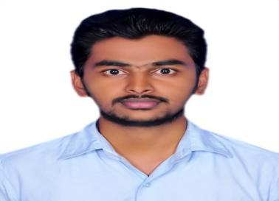
SAKEER

E-mail: sakeer-393528@2freemail.com

CAREER OBJECTIVES:

To work in an environment where I can utilise and expand my knowledge in management there by gaining experiences and achieving business related goals.

WORK EXPERIENCE:

Worked as Customer Service during 2nd June 2017 to 4th October 2018.

EDUCATIONAL QUALIFICATION:

- Completed Masters in Business Administration with Finance and Marketing specializations at Sree Narayana Guru Institute of Management Studies, Coimbatore, affliated to Anna University, Chennai with 67% during 2017.

- Completed Bachelor of Commerce from Co-Operative College, Alathur, Palakkad Affilated to University of Calicut with 59% during the year 2015.

- Completed Higher Secondary under State Board of Kerala from SM Higher Secondary School, Ayalur, Palakkad with 65% during the year 2012.

- Completed SSLC under State Board of Kerala from M.N Krishnaiyer Memorial Higher Secondary School Chittilanchery, Palakkad with 65% during the year 2009-2010.

COMPUTER SKILLS:

- Operating System

- MS Office

- Tally ERP 9.0

KEY SKILLS:

- Leadership quality and smart working nature

- Good motivation and communication skills

- Ability to handle pressure situation

AREA OF INTEREST:

Finance-Accounts, Portfolio Management.

PERSONAL DETAILS:
Father’s Occupation | : | Agriculturist
Date of Birth | : | 1st May 1995
Gender | : | Male
Marital status | : | Single

LANGUAGES KNOWN:
LANGUAGES | READ | WRITE | SPEAK
English | ✓ | ✓ | ✓
Hindi | ✓ | ✓ | ✓
Malayalam | ✓ | ✓ | ✓

HOBBIES:

Playing Cricket, Surfing, Travelling

VISA TYPE: Visit

DECLARATION:

I hereby declare that all the information mentioned above is true to the best of my knowledge and belief.

Place:
Date:

Signature

(SAKEER)

