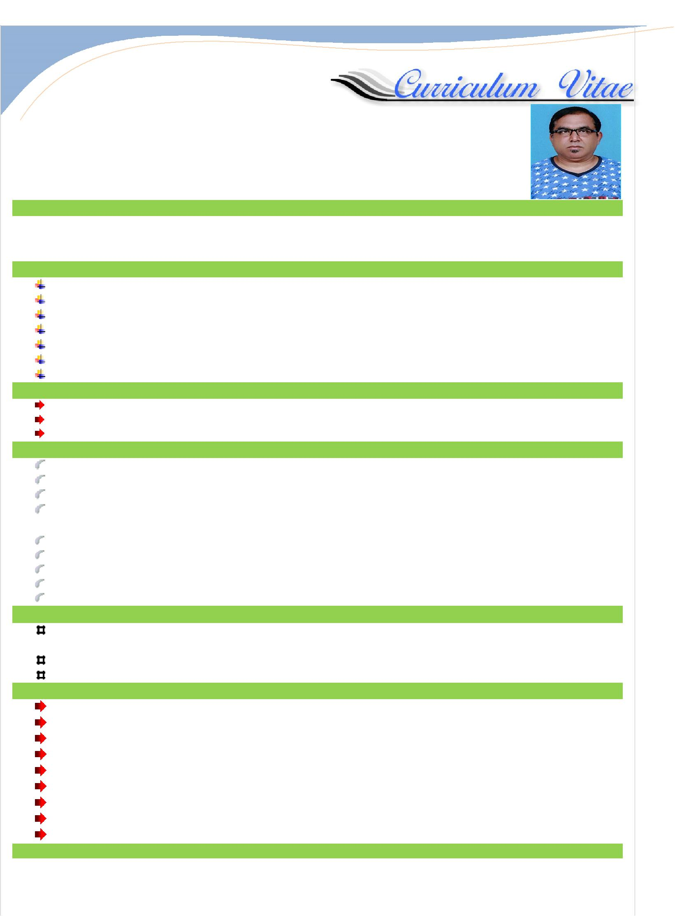

AJITH

Email: ajith-393560@2freemail.com
Dubai, U.A.E

POST APPLIED FOR: DRIVER
OBJECTIVES
Goal oriented and Enthusiastic post-graduate with work experience. Team player with excellent communication and Time Management Skills along with Analytical, problem-Solving and focused approach to work.

PERSONAL DETAILS
Name | : | AJITH
Date of Birth | : | 3rd March 1977
Gender | : | Male
Religion | : | Hindu
Marital Status | : | Single
Nationality | : | Indian
Languages Known | : | English, French,Arabic, Hindi, Tamil and Malayalam
EDUCATION QUALFICATION
Higher Secondary Education
Secondary School Leaving Certificate
BA (English)
PASSPORT DTAILS
Passport Details
Date of Issue | : | 16.06.2015
Date of Expiry | : | 15.06.2025
Visa Status | : | Employment
LICENSE DETAILS
Date of Issue | : | 29.11.2015
Date of Expiry | : | 29.11.2025
Permitted Vehicle | : | Light Vehicle- (Automatic)
Place of Issue | : | Dubai-UAE
PROFESSIONAL EXPERIENCE:

Currently working as a “Limousine Driver” in Dubai-UAE since 1 year 8 months to till date

Worked as a “Taxi Driver” in Abu Dhabi-UAE – for 1.5 years. Worked as a “Tourist Taxi Driver” in Mauritious for 03 Years

SKILLS:
Having valid driving license issued from UAE
Well knowledge of Light Vehicle Driving
Knowledge about Routes and location around the all UAE
Service oriented to ensure customer satisfactions, excellent social & communication skills.
Matured individual with tact and diplomacy, disciplined and accurate.
Enthusiastic and committed
Work effectively both as team member and independently Strong administrative and organizational skills

Good communication, writing, and organizational skills
DECLERATI.ONS
I certify that the above are true and correct to the best of my knowledge and ability. If given a chance to serve you, I assure that I will execute my dutiesfor the total satisfaction of my superior.

AJITH

