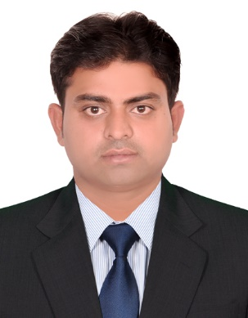
NITIN

E-Mail: nitin-393460@2freemail.com

MECHANICAL ENGINEER PROFESSIONAL
Hands on experiencein the arena ofProcurement / Estimation/ Contract Management / Project Operation / Planning, Scheduling & Controlling/ Budgeting

Competent Mechanical Engineer professional with hands on experience to review engineering drawing, specification, contract documents and client requirements. Preparation of BOM / BOQ and estimation. Possess good knowledge in planning, budgeting& earned value management. To assist preparation of budget, analysing Estimate to complete (ETC) and Estimate at completion (EAC) to avoid budget over run.

Hands on experience in diverse industries like HVAC & CHW.

Competencies:-

Estimation Procurement Contract Management

ORGANISATIONAL EXPERIENCE

- Since Aug 16 – Sep 18

Worked in the fabrication department of HVAC ducting, Assisted in scaling and fabrication of different types of ducts. Gained in knowledge on different types of fabrication methods and materials GI, PI, AL & FIRE RATED SHEET, etc. that are used for ducting& AL cladding.

PRESENTLY WORKING

- Since Oct 18

(AL SABBAH is the member of AL FARA group)
Presently I am site engineer In DUBAI CREEK HARBOUR VIEW in DUCTING division & CHW
Division.

HARBOUR VIEW: - The Elegant 51 floor twin towers are home to more than 750 one, twoand
Three bedroom and penthouse apartments, which are anchored to a three – level podium, with
Podium level apartments and 14 two – storey villas / town house enjoying direct access to the luxury
Pool and other podium amenities.

- HVAC Engineering

- Review of engineering drawing & specifications.
- Preparation of BOM / BOQ and estimates
- Prepare contract documentation for procurement of services and material.

Presently working in the site, duct installation of HVAC ducting, RISER, FCU, VDC, FIRE DAMPER and FAN, SOUND ATTENUATORS etc.Assist in prepare the estimation of BOQ, scaling and fabrication of different types of ducts. Gained in knowledge on different types of fabrication methods and materials that are used for duct installation.

EDUCATION

- Bachelor of Engineering:

Bachelor of technology (B.Tech) in Mechanical with 7.43 CGPA 2012-2016
Bhagwant Unversity Ajmer, India

- HIGHER SECONDARY CERTIFICATE (HSC):

Rastriya inter mediate college 2011
Sujanganj Jaunpur UP

- SECONDARY SCHOOL CERTIFICATE (SSC):

Rastriya inter mediate college
Sujanganj Jaunpur UP 2009

COMPUTER SKILLS

- AutoCAD
- SolidWorks
- Well versed with Microsoft Word, Excel and PowerPoint

PROJECTS SUBMIT

- ELEVATOR – FINAL YEAR PROJECT

An elevator or lift is a vertical transport vehicle that efficiently moves people or goods between floors of a building. It is connected to a rope or chain hoists and the pulley. Elevator is use to go for one floor to other floor.

PERSONAL

- Possessing good soft skills competency
- Constantly in pursuit for new experiences and knowledge
- Driven by sheer force to achieve goals and expectations
- Diligent, time efficient and adaptive to any challenges

PERSONAL DETAILS

Name: Nitin
Date of Birth: 2 Feb 1994
Languages Known: English, Hindi
Nationality: Indian
Marital Status: Married
Visa Details: Employee visa
Driving License: UAE, India
Passport Details: Valid till 2023.

