CURRICULUMVITAE
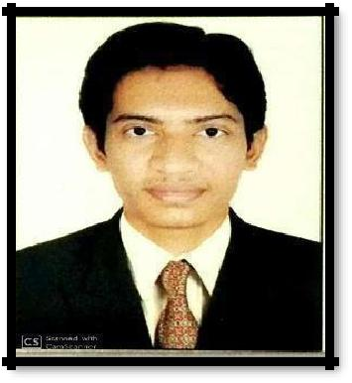

Mr. SUBODH

CIVIL ENGINEER

Bur Dubai

Visa status : Visit visa 3 months.

MailID:- subodh-393659@2freemail.com

OBJECTIVE

- I am Diploma + B.E Civil Engineer highways and have 4 years of professional experience in Construction.

- Supervision of Highway (roads), Bridges and other Civil Engineering Projects aided by World Bank and NHAI Project.

- I have been extensively engaged in Construction Supervision, Quality Control of road works, Earthwork, sub grade, sub base, base course and bituminous work, earth moving equipment and automatic sensor Paver finishers confirming MORT & H Specifications.

- My professional experience also covers quantity calculation as per specifications. Preparation/verification of Contractor's bills etc. work verification as per contract specification and drawing monitoring of execution of works, quality assurance.

WORKEXPERIENCE:

Employment Summary

1. (August 2018 to till date)

Highway Engineer

(Chetak Enterprises ltd, Client NHAI)

Strengthening and widening of existing 4- lane road to 6-lane dual carriageway of NH-8 (Shamlaji – Choiloda section) in the state of Gujarat. Responsible for construction supervision of 93.400 KM Long National Highway costing 1270 crores Flexible Pavement with embankment, Sub-grade, sub - base (GSB), Base -Course (WMM), Bituminous Macadam, DBM, Bituminous Concrete.

Assignment:-

- Supervise the works on day-to-day basis as per the work programme of the Concessionaire.

- Review and forwarded to senior for approval of the works programme of the Concessionaire.

- Identify Construction delays and recommend to the Concessionaire the remedial measures to expedite the progress.

- Monitor the works done by the subordinates on daily basis and guide for smooth working as

per contractual clauses, as per specifications and as per plan and profile.

2.N.G Projects Ltd (June 2015 to August 2018)

Client:-Stanley Consultant Inc.

Strengthening and widening from Km 29+681 to Km 68+417 of SH-11 (Dabhoi - Bodeli section) in the state of Gujarat. Responsible for construction supervision of 28.736 KM Long National Highway costing 119 crores Flexible Pavement with embankment, Sub-grade, sub - base (GSB), Base - Course (WMM), Bituminous Macadam, DBM, Bituminous Concrete.

Relevant Skills:

Electronic Data Processing Knowledge:

Excellent in Microsoft Office Program:

MS Word: Excellent skills in editing typing and maintaining documents.

Excel Spreadsheets: Professionally trained in using MS Excel skills. Excellent skills to create and maintain Excel sheets on daily basis.

EDUCATIONALBACKGROUND:

Diploma (Civil Engineering), Gujarat Technological University, 2015 (62.66%)

B.E. (Civil Engineering), Ram Krishna Dharmarth Foundation 2018

LANGUAGES:

English: Fluent in speaking and writing

Gujarati: Mother language

PERSONALINFORMATION:

Nationality: Indian

Marital Status: Single

Date of Birth: Sep 22, 1991

Place of Birth: Mumbai (India)

