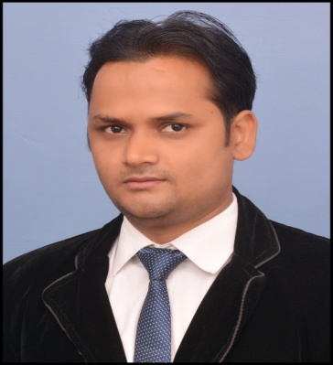
Curriculum Vitae
Sayeed
{Primary & Assistant Teacher }
E:mail- sayeed-393665@2freemail.com

CTET & B.Ed Teaching Professional more than 5+ Years experience.

CAREER OBJECTIVE
To achieve a respectable position by sharing, gaining the Knowledge & serving the respective organization with best effort & skills. Where I can give my best to that organization and I can take challenges and hard work under pressure.
ORGANIZATIONAL EXPERIENCE

Place: Gonda, UP, India
Designation: Primary Teacher
Worked Since: March 2017 to Present
JOB PROFILE:
- Planning, preparing and delivering lessons.
- Helping pupils improve their listening, speaking, reading and writing skills via individual and group sessions
- Preparing teaching materials.
- Checking and assessing pupils’ work.
OTHER EXPERIENCES
- Worked as a Center manager,Bahraich.
Duration (March 2015 to Feb 2017).
- Worked as a Maths Teacher in Bahraich.
Duration (July 2011 to June 2012).

EDUCATION QUALIFICATION
PROFESSIONAL QUALIFICATION
- Bachelor of Education (B.Ed) from Lucknow University, Lucknow UP (India) year 2015.
ACADEMIC QUALIFICATION
- Masters in Arts (M.A) from Dr. Ram Manohar Lohiya University Faizabad-(Year2013)
- Bachelor in Arts (B.A) from Jamia Millia Islamia University New Delhi-(Year 2005).
TRAINING CERTIFICATES ACHIEVEMENTS
- Completed Central Teachers Eligibility Test from CBSC in 2015.
- Completed Six months Basic Computer Certificate from NITS, Lucknow in 2013.
- Jan Pragati Educational Project for Unbearable pupil’s Education in 2015.

COMPUTER SKILLS:
Software: MS Word, MS Excel, MS Power Point, Card Shop, Instant Artist

INTREST & ACTIVITIES:
- Strong relationship building.
- Performing innovative presentation.
- Occasional singing and music.
- Playing Chess & Cricket

CORE COMPETENCIES
- Effective Communication Skills
- Negotiate Convincing Skills.
- Good organizational and planning skills.
- The ability to lead and motivate a team.
- An initiative person who has a positive attitude to everyone.
- Capability of understanding and implementing modern techniques quickly

PERSONAL INFORMATION
DOB - 04th May, 1985
Sex - Male
Languages- English, Urdu & Hindi
Marital Status- Married
Nationality- Indian

PERSONALITY TRAITS:
Everything is possible with perseverance and true inclination in the right direction. The information above provided is true to the best of my knowledge and belief. I agree to abide by the rules and regulation of organization.

Dated:

Place: (Sayeed )

