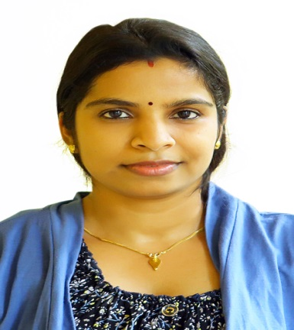
Curriculum Vitae

Divya
Divya-393666@2freemail.com
Dubai

- Objective
Seeking a position to utilize my skills and abilities in organization that offer’s professional Growth while being resourceful, innovative and flexible.

- Qualification
- MBA in FINANCE from BARKATULLAH University, in 2009-2011, 73%
- B.Sc. (Computer Science) from BARKATULLAH University, in 2009, Secured 77%
- Class 12 CBSE scored 70.4%
- Class 10 CBSE scored 78%

- Work Experience

- As Assistant Branch Head in India from August 2012 to February 2014.

- Report immediately to the branch head in the Management department
- Direct interaction with the clients.
- Prepare letter of correspondence.
- Making sure to meet the deadlines.
- Manage the cash reserve, sanctioning loans
- Creating new customers profile.
- Maintains HNI list.
- Checking NPA and do the alternates

- As an accountant in India from March 2012 to July 2012.

- Documents financial transactions by entering account information
- Prepare invoices and daily updating
- Making RTGS and NEFT transactions
- Monitoring stocks
- Report to management regarding the finances of establishment.

- As a Trainer at SHWEF (NGO) from December 2011 to March 2012

- Maintaining data records and arranging them in tabular form
- Preparing presentations for Government projects.
- Visiting under privileged area and concerning with their issues.

- Technical skills

- MS Office
- C language
- Knowledge of Tally. ERP 9

- Personal Dossier

- Date of Birth : 20/07/1988
- Marital Status : Married
- Visa status : Husband Visa
- Nationality : Indian
- Language Known : English, Hindi and Malayalam

- Strengths
- Ability to work in new and challenging environment.
- Willingness to learn new concepts, ideas and use new technologies.
- Proactive and positive attitude
- Extremely efficient, diligent, honest and adaptable
- Proven ability to work in team and independent environments
- Creative and committed with an ability to perform under pressure and competitive situation

I declare that the above information is true to the best of my knowledge.

Place:Dubai
Divya

