NASEEBA

LAB TECHNICIAN(HAAD Qualified)

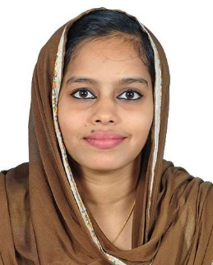

OBJECTIVE
Seeking for a challenging opportunity to be a part of an integral organization that offers career growth, self-development and long-term prospects assuring my commitment, sincerity and diligence in work.

EDUCATION
Diploma in Medical Laboratory Technology
Certificate of Higher Education
Institute : EMS College of Paramedical Sciences.(2015 Dec)

PERSONAL DETAILS
Nationality : Indian Marital Status : Married Visa Status : Visit Visa

CONTACT

EMAIL:
naseeba-393718@2freemail.com

PROFILE SUMMARY
Certified Medical Lab Technician with 2+ years of experience performing hematology tests in a fast-paced laboratory environment. Passionate about helping diagnose and prevent illnesses and diseases.

WORK EXPERIENCE
Kerala, India

Laboratory Technician [Mar 2016–May 2018]
Set up and sanitize laboratories Prepare specimens
Match blood compatibility for transfusions Analyze fluid chemical content
Collect blood samples
Examine immune system elements Labelling and reagent storing
Handled sophisticated laboratory equipment that included:
- Beckman Coulter AU480 Biochemistry Fully automated analyzer
- Beckman Coulter ACCESS 2 Immunoassay System Hormones Fully automated analyzer
- SYSMEX XS 5-part (cell counter)
- EasyLyte (Na/K/CL analyzer)
- AGAPPE Mispa i2 Nephelometer
- ERBA CHEM-5 plus V2 (semi auto analyzer)
- (Auto clave, hot air oven, incubator, centrifuge, etc.)

AREAS OF WORK:

- Microbiology
- Hematology
- Blood Banking
- Immunology
- Clinical Chemistry
- Molecular Biology
- Cytotechnology

I hereby declare that the information furnished above is factual and correct to the best of my knowledge and belief. Reference will be provided upon request.

Naseeba

