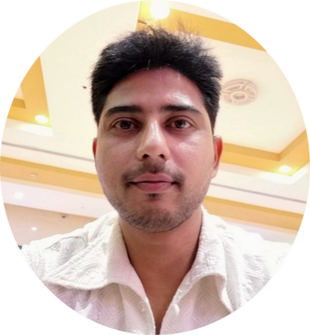

**29**

**F**

**e**

**b**

**r**

**u**

**a**

**r**

**y 1988**

**Graphic Designer**

Visa Status: Employment Visa Valid till May 2020

Dubai, UAE.



[Sarfaraz-393725@2freemail.com](mailto:Sarfaraz-393725@2freemail.com)

**Software Knowledge**

**Software Knowledge**

**Id**

**Af**

Sarfaraz

**Ps**

31 Years Old, Indian, Married.

**Ai**

Fast & Self Learner.

**Cdr**

**Bike Licenced**

**UAE and Oman**

**Ps**

**Education**

**Ae**

**Ad**

**Cd**

H.S.C From Kolhapur Board 2006-07.

Bachelor of Computer Arts & Designing (Diploma) From Softpro Computer Education (Mumbai) 2014.

TO BE CONTINUES….

**Ae**

**Dr**

**Current Role**

**Current Profile**

**Responsibility**

Maintain containers track records (Pics& Documents Details).

Photoshoot for Company Products.

Images editing & create new attractive products images

Create new catalogue for website as well as maintain original HD quality pics& Backup the files & Designs.

Uploading images on company server daily for Computer & Tablets.

Performs related duties as required.

Contributes to team effort by accomplishing related results as needed.

Study design brief and determine requirements.

Develop concepts, graphics layouts for product illustrations and websites.

Prepares layouts, designs, artwork and formats for use in publication or exhibition designs.

Maintain a polished, organized and updated design archive.

Produces high quality designs for social Media Platforms and the website.

Thinks creatively and develop new design concepts, graphics and layouts.

Join images with background graphics and special effects.(Manupulation)

And Many mores…….

**Professional Experience**

**In Dubai, UAE**

As Designer since 28 March 2018----Till Date Presents….

**in India**

In-Charge Cum Graphic Designer – 08 March 2017 To 23 March 18. 2018.

**Adnet Global Private (India) Limited. (Digital Media)**

Graphic Designer (Jr.Executive) - 1 Year.

**Only For You Private (India) Limited. (Fabric Printing)**

Graphics Designer (Editing Fashion Designer) - Dec.17 2014. To 31 Dec. 2015.

**Key Skills**

**Language**

**Kaftan Design (Apparel), Catalogue, Banners, Brochures, Flyers, Manupulation, Image Retouching, Logo,Color Knowledge, Signage, Photography.**

**Language**

English , Hindi, Marathi.

PROFESSIONAL EXPERIENCE