CURRICULUM VITAE

SIKANDER

ABU DHABI, UAE  
  
Email: [sikander-393739@2freemail.com](mailto:sikander-393739@2freemail.com)

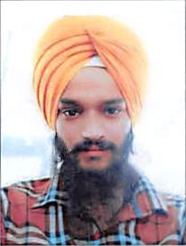

Job Applied for " JCB , BACKHOE LOADER &F0RK LIFT OPERATOR "

To work in an environment which offers a good opportunity to share my knowledge and skills with others and participate myself and work towards for a complete satisfaction of the

|  |  |
| --- | --- |
| company. | |
|  | |
| Nationality | : INDIAN |
| Date of Birth | : 17-08-1995 |
| Gender | : Male |
| Marital Status | : Single |
| Language Known | : English, Hindi & Punjabi |
|  |  |

+2

2 year Hard ware & soft ware course

Self-motivated & capable to mix easily with different situation

Hard Worker and Honest

Disciplined and Team Worker

Perform Assigned task with grant responsibility

Sincere and result oriented & Good Communication skills

|  |  |
| --- | --- |
|  | |
| **Passport Details** | N |
| V Date of Issue | 17-05-2016 |
| > Date of Expiry | 16-05-2026 |
| > Place of Issue | AMRITSAR |
| iLicense Details 1 | |
| > Date of Issue | 12-12-2018 |
| > Date of Expiry | 12-12-2020 |
| > Place of Issue | DUBAI |
| > Permitted | : Heavy Tractor |

4- 02 years working as a JCB & FORK LIFT OPERATOR in india.

^ Now presently working as a JCB OPERATOR in Abu Dhabi UAE. 25-01-2019 TO TILL DATE.

I hereby declare that the above furnished information are true and correct in best of my knowledge and belief.

SIKANDER