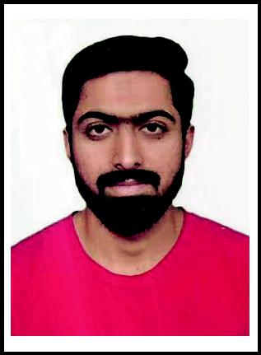
HAFIZ

Hafiz-393744@2freemail.com

SUMMARY:

EDUCATION:

COMPUTER SKILLS:

KEY SKILLS:

EXPERRIENCE:

LANGUAGES:

REFERANCE:

Seeking a career with a career oriented and civil organization that can provide me the platform for becoming a well-recognized professional and ultimately attending prestige and pride for the organization and for myself as well.

BS CT (Bachelors of Civil Technology) (2014-2018)

1st division UNIVERSITY OF LAHORE (Chenab Campus) Gujrat FSC (Pre-Eng) (2012-2014)

2nd division Board of Intermediate Education GUJRANWALA Matriculation in science (2010-2012)

1stdivision Board of Intermediate Education GUJRANWALA

• Auto-Cad 2D & 3D | • Cad Cam
- Dev

- Endnote

  - Microsoft Oﬃce (Word, Excel, Power point and Access)

Price the cost of the different materials needed for the project

Prepare tender documents, contracts, budgets, bills of quantities
Track changes to the design and/or construction work

Procure or agree the services of contractors

Subcontractors who work on the construction of the project Measure and value the work done on site

QUANTITY SERVAYOR;

PAKISTAN (2018-2019)

Prepare periminilary coﬆ eﬆimate and plants of development projects.

Prepare financial ﬆatement of regular intervals during conﬆruction period.

Prepare and execute format contract.

Prepare bill of quantity of specification document for tendering.

ENGLISH

HINDI

URDU

Reference will be on demand.

