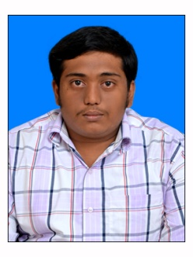

FAIZAL

E-mail: faizal-393745@2freemail.com

PROFICIENCY:

To pursue a career in a renowned firm with dedicated efforts and to associate myself with an organization that gives me a chance to enhance my knowledge and experience.

EDUCATIONAL QUALIFICATIONS:

- Completed MBA in Bharathidasan University (2017) Tiruchirappalli, India with First Class (Specialization in finance)
- Completed B.COM in Bharathidasan University (2015) Tiruchirappalli, India with Second class

AREAS OF INTEREST:

- Finance & Accounting
- Sales & Marketing

SOFTWARE EXPOSURE:

- Basics of MS office
- Tally Accounting Package ( ERP 9.0)

EXPERIENCE:

Worked as a Processor at Thanjavur (Jan’18 to Aug’18).
Worked as a Accountant at Thanjavur (Dec’18 to Jul’19).

Responsibilities:

- Maintain a Ledger of Sales and Journals.
- Maintain a Daily vouchers.
- Maintain a Student Enrollment (New Joining).
- Maintain a Quarterly basis accounts and Tax related queries.

SKILLS:

- Positive attitude and energetic in nature
- Proactive and good planner
- Ability to adopt in a new environment easily
- Management reporting skill
- Target driven and self-motivated
- Ability to work under stress

PROJECTS UNDER TAKEN:
- Computer Application In Business Lab (B.Com)
- Profitability Analysis In Bank Of Baroda (MBA)

ACHIEVEMENTS:
- Participated in National Conferences On “Services Sector In India – An Analysis” Organized by Research Department Of Commerce

- Participated in National Level Management Meet Organized by Department of Business Administration

- Participated in one day special lecture on “Investment awareness through mutual funds”, Conducted by Department of Management Studies

PERSONAL DETAILS:

D.O.B : 11.12.1994
Gender : Male
Marital Status : Single
Nationality : Indian
Languages : Tamil, English, Hindi and Urdu.
VISA Status : Visit Visa Up to 15 Oct'19

REFERENCE:

Available upon request.

