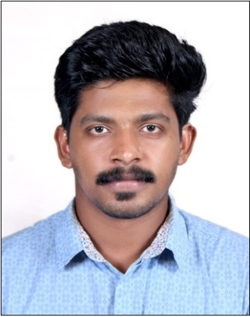 |  | Aneesh  - WEB DEVELOPER BE. Computer Science  Enrichment of skills through competitive environment, sincere effort towards achievement of organizational goal and self-upliftment through technical knowledge & interpersonal skills
My Profile  Nationality: Indian  Date of Birth: 02/09/1992  Gender: Male  Visa Status: Visit  Languages: English, Hindi, Malayalam.  Contact  EMAIL: aneesh-393776@2freemail.com  SKILLS  - PHP, SQL, CSS, HTML, JavaScript.  - WordPress, CodeIgniter.  - Digital marketing  - Sales and Marketing ideas  - Creativity and Problem-Solving Ability. |  | EDUCATION  SSLC – ST Theresa’s HSS Vazhappally, Kerala.  [ From 2009 – to 2010]  Higher Secondary – AVHSS Kurichy, Kerala.  [from 2008 – to 2010]  B E. COMPUTER SCIENCE – SDIT, MANGALORE.  [from 2010 – to 2015]  WORK EXPERIENCE  [PHP Web Developer]  Thiruvananthapuram, Kerala  [From 2016 Aug to 2017 Oct]  Project Details  : Project 1- Parents students Association Front end: PHP  Back end: MySQL  : Project 2- Online restaurant food ordering system  Responsibilities  - Adding new customers into JOO Product.  - Developing independent websites for the customer.  - Configuring payment gateways for them.  Few websites done: https://www.yallabeirut.co.uk/ http://al-aminkingston.co.uk/ https://rajbaripenketh.com/  [Relationship Officer]  Kottayam, Kerala  [From 2018 to 2019 Jun]  Responsibilities  • Meet with applicants to obtain information for loan applications and to answer questions about the process  • Explain the customers the different types of loans and credit options that are available, as well as the terms of those service.  • Analyze applications financial status, credit, and property evaluation to determine feasibility of granting loans  • Submit applications to credit analysis for verification and recommendation.  • Approve loans within specified limits and refer loan applications outside those limits to management for approval.

