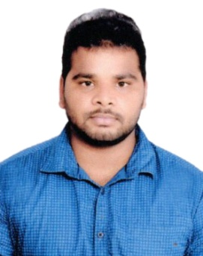
NAGENDRA DUBAI, U.A.E. E-mail: nagendra-393790@2freemail.com

OBJECTIVE (ACCOUNTANT)

To obtain an Accountant position by adding value through utilising my superior knowledge prospecting and calculation abilities in the business and build up a career in a reputed concern. Where I can utilise my skills and experience from Asian Gold 10-D Private Limited, Hyderabad, acquired practical knowledge in tally applications and implementations.

WORK EXPERIENCE

Accountant and Store In charge in Hyderabad from 1/06/2018 to31/5/2019.
Duties in Firm:
- Maintain all accounting voucher entry.
- Maintain Bank Reconciliation.
- Maintain day to day accounts.
- Coordinate monthly payroll functions for employees.
- Maintain store activities.

EDUCATIONAL QUALIFICATIONS

SUBJECT | BOARD/UNIVERSITY | YEAR OF PASSING | PERCENTAGE
MBA(finance) | BVCITS – affiliated by JNTUK | 2018 | 71%
B.COM(Comp) | SBMM degree College affiliated AKNU | 2016 | 65%
INTERMIDIATE | VIDYANIDHI Jr College (Board of Intermediate) | 2013 | 77%
SSC | KENNEDY CONVENT (Board of Secondary Education) | 2011 | 85%

TECHNICAL SKILLS

- MS WORD
- MS EXCEL
- TALLY ERP 9

INTERNSHIP EXPERIENCE

- Topic : WORKING CAPITAL.
- Duration : Four weeks.
- Venue : Godavari Delta Paper Private Limited.
EXTRA-CURRICULAR ACTIVITIES

- I have attended workshop on “Business model innovation – current drivers” by i2E at GITAM UNIVERSITY, Visakhapatnam.
- I was an active member of “HORIZON-2K17” BVCITS College, in the event of College.
- I have been a volunteer at Sahaya Foundation
- Active participation in school and college, personality development activities.
- Active participant in Cultural Programs

LANGUAGES KNOWN

- TELUGU
- ENGLISH
- HINDI
STRENGTHS

- Hard working and good communication skills.
- Adaptable to changes and new situations.
- Enthusiastic to learn new things.
- Mingle with others easily.
- Optimistic Attitude.
- Self confidence.

PERSONAL DETAILS

My Date of birth : 04-Aug-1996
DECLARATION

I hereby solemnly declare that the above furnished details are true to the best of my knowledge and I assure that I would put all my abilities and efforts to maximize my usage to the company for safe development.

( NAGENDRA)

