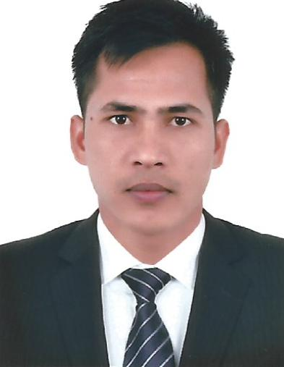
Resume

Maan
Email: maan-393807@2freemail.com
Dubai, UAE

Objective

To work in the private sector and make innovative and creative changes in the field of marketing and sales where my leadership and management skills will be fully utilized.

Profile

- Self-driven, aggressive professional with an eye for detail and a focused approach to any challenge
- Capable of working with deadlines, with quick to grasp new ideas and leadership prospects as well as additional responsibilities a committed team leader
- Well versed in today trends and understands the advertising sphere.

Organizational Experience

Working as a Merchandiser in Dubai UAE (June 2015- present )
- Achieving sales Target
- Team work
- Customer service
- Responsible to Business Growth and Development
- Requisition new stock, get arrange and display merchandise.
Worked as a SeniorFC in India (Feb 2013 Feb 2015 )

- Key Responsibilities
- Achieving sales target
- Pilferage control
- Grooming, Discipline
- Coordination with other staff member
- Customer service
- Responsible to Business Growth & development.
- Requisition new stock, get arrange and display merchandise.
Worked as a Customer Relationship Offcer in India ( Dec 2012 - Jan 2013 )
- Protects employees and customers by providing a safe and clean store environment.
- Contributes to effort by accomplishing related results as needed.
- Maintains the stability and reputation of the store by complying with legal requirements.
- Contributes to team effort by accomplishing related results as needed.

Academic
- 12th From HSEB Board Nepal.
- 10th From SLC Board Nepal.
Professional Qualification
- Basic knowledge of computer

STRENGTH
- Excellent communication skills
- Strong client management skills.
- Excellent time management and organizational skills.

Personal profile
Date of birth :19/02/1989
Marital Status : Married
Nationality : Nepalese
Languages known : English, Hindi& Nepali
Place : Dubai,UAE

