CURRICULAM VITAE

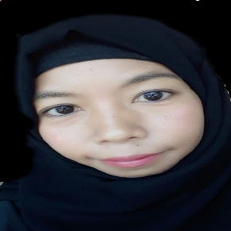
RUBY
Dubai, U.A.E.
Email: ruby-393830@2freemail.com

Post Applied: ANY SUITABLE JOB

CAREER OBJECTIVES:

To obtain a challenging and responsible position in an organization where I can utilize my capability and experience, which would contribute to the growth and success of the organization.

WORKING EXPERIENCE:

- 03 Months working experience as a Office staff in Samar.
- 03 Months working experience as a Office Assistance in Philippines.
- 04 Months working experience as a Assistance Social worker in Philippines.

- 04 Months working experience as a On Job Training/office work in Philippines.
- 01 Years working experience as a Credit enterprise Officer, in Philippines.
- 01 Years working experience as a School Cashier in Philippines.
- 02 Years working experience as a cashier at Muscat.
- 02 Years working experience asa Receptionist at Muscat.
- 01 Years working experience as a Personal Secretary in Philippines.
- 01 Month training as a caregiver in Malaysia.
- 02 Years working experience as a Personal Secretary in United Arab of Emirates.

EDUCATIONAL QUALIFICATION:

- Bachelor’s Degree (major in Banking and finance)

PERSONAL DETAILS:

- Religion : MUSLIM
- Nationality : PHILIPPINES
- Date of Birth : 03/09/1988
- Marital Status : MARRIED
- Languages known : ENGLISH,TAGALOG,BASIC ARABIC
- Visa Status : EMPLOYMENT VISA ( NOC AVAILABLE)

PASSPORT DETAILS:

- Place of Issue : DFA NCR NORTH PHILIPPINES
- Date of Issue : 27/11/2016
- Date of Expiry : 26/11/2021

PERSONAL APPRAISAL:

- Good organization skills.
- Able to work under pressure and meet deadlines.
- Team work.

DECLARATION
I hereby declare that all the above information is true and correct to the best of my knowledge and belief and I am ready go carry out any tasks.

