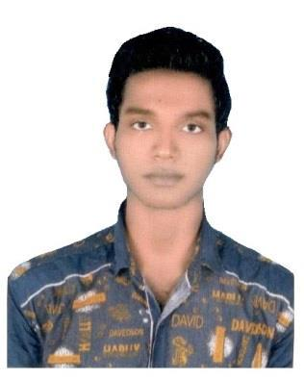
IMRAN

Email: imran-393839@2freemail.com
Deira - Dubai

OBJECTIVE

Seeking a challenging position in a reputed organization where I can fully utilize my professional skills for my personal development, experience and knowledge for the development of the company.

HIGHLIGHTS

Worked as an Engineer –India
From 08-06-2015 To 30-08-2016
EXECUTIVE DIGEST

- Researched new technologies and materials, and recommended best options to supervisor for new product development to reduce equipment down time

- Applied design principles including strength of materials science and stress analysis during design process

- Attended monthly company meetings and contributed ideas which were incorporated into company’s SOPs

- Communicated regularly with Production staff to document equipment errors and malfunctions

- Thoroughly maintained and troubleshot faulty equipment
- Worked effectively with a multidisciplinary team and developed excellent

communication and problem solving skills
COMPUTER SKILLS

- MS Office (i.e. Word, Excel)

- Good knowledge of internet and E-mail Communication

- Familiar Environments(i.e. Windows XP, Windows 7)

ACADEMIC QUALIFICATION

- Mechanical Engineering – Three years Diploma – 2012-15 Result= 70.4%

At C T Polytechnic College, Shahpur, Jalandhar

- Matric Pass -2012. Result= 70%

B S E B Patna in Bihar- India

ADVANCE QUALIFICATIONS

- TIG (Tungsten Inert Gas)
- MIG (Metal Inert Gas)
- FLUX
- DRILLING
- BORING
- GRINDING
- MACHINING
- GROOVES WELDING (1G,2G,3G,4G,5G,6G)
- FILLET WELDING (1F,2F,3F,4F)

INFORMATION

DOB | : | 25th Jan 1995
SEX | : | Male
Marital Status | : | Single
Nationality | : | INDIA
UAE Visa | : | Employment Visa (Exp: 07-02-2020)
Declaration

I hereby declare that the information furnished above is true to the best of my knowledge and belief.

IMRAN

