H V A C D E S I G N I N G A N D D R A F T I N G E N G I N E E R

F A R S H A D
Email: farshad-393870@2freemail.com

FARSHAD’S VIRTUES
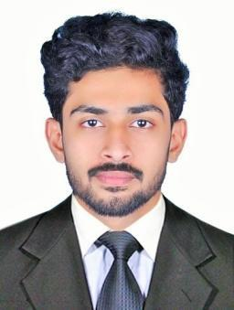

OPTIMISTIC| DEDICATED IN WORKS| SELF CONFIDENT

EDUCATION

Bachelor of Technology in Mechanical Engineering [2014-2018]
(Affiliated to Calicut University)
Calicut University Institute of Engineering and Technology, Malappuram, Kerala.
With an Overall CGPA of 6.55

PLUS TWO
MVHSS, Ariyallur, Kerala.
With an Overall percentage of 86.83

TENTH
CRHSS, Velimukku, Kerala.
With an Overall percentage of 81

WORKEXPERIENCE

- Worked as a full time HVAC Engineer in Bangalore from December 2018
– may 2019.

- Worked as a trainee for HVAC Design and Drafting in Bangalore from October 2018 – November 2018.

PROJECT AND SEMINAR

Project: Portable Thermoelectric Refrigerator

Produce a small portable Refrigerator (Dimensions: L=176mm B=176mm H=286mm) using ‘Thermoelectric Module’.

Seminar: A Critical Review on Different Types of Wear of Materials
Discuss the various types of wear mechanism and different lubrication process.

TECHNICAL SKILLS

- HVAC Designing and Drafting.
  - Heat load calculation (Manual, HAP & E-20 sheet).

  - Ventilation Criteria (Kitchen & Car park).

  - Selection of machine.

  - Duct sizing (Velocity reduction & Equal friction method).

  - Different types of duct.

  - External static pressure calculation (In straight duct & standard equipments).

  - Pipe sizing & Head loss.

  - AHU, FCU, VRV, VRF, Package unit & DX-system.

  - Bill of quantity.
- AutoCAD 2d & 3d.
- Microsoft Excel, Microsoft word, Microsoft power point.

INTERPERSONAL SKILL

- Dedicated in works.
- Confident and Determined.

- Ability to cope up with different situations. o Hard Worker.

o Good team worker.
o Interested to learn new technology.

PERSONAL DETAILS

Sex

Date of Birth

Languages Known

Marital Status

Nationality

Religion

Interest & Hobbies

Visa status

: Male

: 14-11-1995
: English, Malayalam & Hindi

: Single

: Indian
: Muslim

: Travelling, Driving, Photography.

: Visiting Visa

DECLARATION

I do hereby declare that the above information is true to the best of my knowledge.

FARSHAD

