Ahtesham
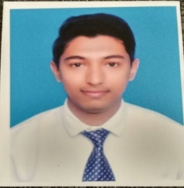
CONTACT Email: ahtesham-393878@2freemail.com

CAREER OBJECTIVE
Looking forward to an opportunity for working in a dynamic and challenging environment, where I can utilize my skills for developing my career and for the growth of the organization

EXPERTISE
- Attentive listening and effective communication skills.
- Great at problem solving.
- Good leadership skills.
- Self-motivated with outstanding time management.
- MS Office

Professional Experience
Currently working as an IT Engineer/Consultant for a trading based company in Dubai.
Experience of more than 2 years as an IT (Information Technology) / Data Analyst.
Experience of more than 2 years as an IT (Information Technology) Executive in Orbit motors Pvt Ltd (Maruti Suzuki Dealership)

Professional Summary

- Microsoft Dynamics NAV | - Microsoft Business Central | - Enterprise Resource Planning (ERP
- Microsoft Dynamics 365 | - Implementations and Reporting | - Business Intelligence
- Financial Management | - SQL Server | - Warehouse Management
- Inventory | - Sales and Purchase | - Administration and Role Center

Educational Qualifications
Exam / Degree | Year | Name of School/College | University / Board
B.Sc. (CS) | 2014 | Government Autonomous College | Sambalpur University
Inter | 2010 | Rourkela Municipal College | CHSE Board
Matriculation | 2007 | City English School | ICSE Board

Personal Profile
Sex : Male
Marital Status : Single
Languages Known : English and Hindi
Nationality : Indian
Hobbies : Reading books, Playing Cricket, Cooking, Listening to music.

Achievements
I have done few web series and a Bollywood films with national award winning director.

Declaration:
I hereby declare that the above-mentioned information is correct up to my knowledge and I bear the responsibility for the correctness of the above-mentioned particulars.

Place: Dubai Date:

